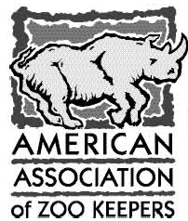
2019 Barbara Manspeaker AAZK Chapter of the Year
Qualification/Nomination Form

Chapter Name: ____________________________

- List Chapter Conservation Projects and Donations to Conservation Projects – 2018. Please highlight donations to AAZK Conservation Partners

2. List Chapter Activities in your Local Community - 2018

3. List How the Chapter has supported your Zoo/Aquarium Facility or Facilities - 2018

4. Detail how the Chapter has supported AAZK Programs Bowling for Rhinos and Trees for You and Me during the Reporting Year - 2018

5. Is 100% of your Chapter Membership, AAZK National Members? | Yes No
6. New AAZK Members Recruited in 2018
7. New Chapter Members Recruited in 2018
8. Change in Chapter Membership (+/- from the previous year)

Each Chapter that completes this Qualification Form and submits the form by the deadline of 15 March will automatically be considered for AAZK Chapter of the Year. Chapters are recognized for their contribution to AAZK based upon monetary contribution to the Association and membership recruitment and retention and for Chapter activity in global conservation, local communities and within their own facilities.
AAZK Chapter of the year is voted upon by the AAZK Board of Directors during the midyear Board of Directors meeting and is awarded during the Annual Conference of the Association

