**Attwater's Prairie Chicken Awareness: Expanding Public Appreciation for a Native in Need**

Mollie Coym

Senior Bird Keeper

Houston Zoo, Inc.

1513 Cambridge

Houston, TX 77030

mcoym@houstonzoo.org

**Abstract:**

The Attwater’s Prairie Chicken (Tympanuchus cupido attwateri) once numbered at least a million along millions of acres of the coastal prairies of Texas and Louisiana.  In 1967, they were listed as endangered and in 1973 they were protected by the Endangered Species Act.  Now these birds are down to just three small tracts of prairie land. This is a species that needs public support if it is to survive. Public funding is needed to continue the captive breeding program and private land owners are essential to the preservation of land for these birds. Unfortunately, many Texans today have not even heard of this bird due to lack of publicity for its plight.

The Houston Zoo Bird Department receives requests several times a year to attend events, have a booth, and educate the public about the Attwater’s Prairie Chickens. With the help of several departments throughout the zoo, we have been able to bring this bird to the forefront of the minds of many more people in the Houston area.

**Introduction:**

The Attwater’s Prairie Chicken (Tympanuchus cupido attwateri) is a species of grouse that is considered to be one of three subspecies of the Greater Prairie Chicken, which also includes the extinct Heath Hen (Tympanuchus cupido cupido) and the Greater Prairie Chicken (Tympanuchus cupido pinnatus).

The Attwater’s Prairie Chicken (Tympanuchus cupido attwateri) once numbered at least a million along millions of acres of the coastal prairies of Texas and Louisiana.  As people became more and more industrialized, more and more native grasslands were plowed for crops and pastures.  By 1919, the Attwater’s prairie chicken had vanished from Louisiana and their numbers in Texas were dwindling.  By 1937, hunting of the Attwater’s ended because only around 8,700 of the birds were left in Texas.  In 1967, they were listed as endangered and in 1973 they were protected by the Endangered Species Act.  Now these birds are down to just three small tracts of prairie land – The Attwater’s Prairie Chicken National Wildlife Refuge (APCNWR), The Nature Conservancy’s Texas City Prairie Preserve (TCPP), and some private land near Goliad, Texas.

So few Attwater’s Prairie Chickens were left in the wild (less than 40), a captive breeding program had to be created to save the species.  The program began in 1992 and the Houston Zoo joined the effort soon after that. The Houston Zoo works in cooperation with five other zoological institutions as part of the Attwater’s Prairie Chicken Recovery Team: Fossil Rim Wildlife Center, San Antonio Zoo, Sea World of San Antonio, Caldwell Zoo, and Abilene Zoo.  These facilities work in conjunction with the U.S. Fish and Wildlife Service, Texas Parks and Wildlife, and The Nature Conservancy in order to help the Attwater’s Prairie Chicken population grow in the wild through captive breeding, rearing, and release into the wild.

The recovery program has seen some success in recent years and the population was slowly growing prior to the drought. For the first time in over 15 years, our pen-reared birds successfully raised chicks that survived to the next season and the population was over 100 birds at the start of 2011. The recovery team hopes to expand by bring a new, dedicated prairie chicken facility onto the team. A lot of funding for the recovery effort comes from the government, which is in danger due to the budget crisis.

The biggest potential for generating support and funding to continue the Attwater’s recovery effort will be to get the public educated and involved. As part of the recovery team, the Houston Zoo strives to educate the public about the plight of the Attwater’s Prairie Chicken, how the Houston Zoo is involved in its recovery, and what they can do to help the effort.

**Objectives:**

The Houston Zoo Bird Department receives requests several times a year to attend events, have a booth, and educate the public about the Attwater’s Prairie Chickens. I requested funds from the Houston Zoo Staff Conservation Fund in order to create a travel kit about the Attwater’s Prairie Chickens that would be taken to speaking engagements and fairs. The goal is to develop a professional looking, fun, interactive, and educational experience for the public attending these events. It should demonstrate what the Houston Zoo does to help recover the Attwater’s Prairie Chicken, engage and educate the public about the Attwater’s Prairie Chicken, and generate pride for a local species and recovery project.

Additionally, I want to raise public awareness of the Attwater’s Prairie Chicken by utilizing social media. With the help of our Interactive Marketing, Graphics, and Conservation Departments, we want to create a following on Facebook. People will become invested in this species, want to learn more, and will become empowered to help.

**Methodology:**

The Houston Zoo has an amazing Staff Conservation Fund that was created to involve all of the staff at the zoo in supporting conservation efforts. Employees can decide to donate a portion of their paycheck to conservation efforts that are being created and conducted by fellow employees. Any staff member at the Houston Zoo can apply for funding to conduct conservation research or education. The applications go through a review process by the Staff Conservation Fund Committee. I applied for a grant from the Staff Conservation Fund to create a travel kit that could be used for events to raise awareness of the Attwater’s Prairie Chicken.

I wanted to create a kit that included engaging materials that are interactive, and move away from using brochures and still photos. I also envisioned having a variety of items that could appeal to both children and adults. The items in the travel kit only cost about $550. This is a very small expense to pay for the impact it can create. The following items were purchased or made for the travel kit:

* A mock up egg candler, with plastic eggs
  + There are a couple of plastic eggs, one with an “embryo” inside and one without
* A mock up egg transport cooler with plastic eggs
* A shadow box with feathers or a nest
* A digital photo frame to have a slide show of APCs
  + This includes a power point presentation of the recovery efforts by the Houston Zoo

The egg candler serves as a hands-on demonstration of how we look at APC eggs in order to determine fertility and monitor the development of the embryo. The mock transport cooler is eye catching and serves as a speaking point to teach the public about our breeding facility at NASA’s Johnson Space Center. It also demonstrates how we safely transport eggs to the zoo from wild nests. The shadow box of feathers gives the public an opportunity to see something up close and real; this aids in connecting them to the Attwater’s. The digital frame is better than traditional still photographs because it is visually appealing and it can be updated at any time. Moreover, I can add text that explains what is occurring in the photos.

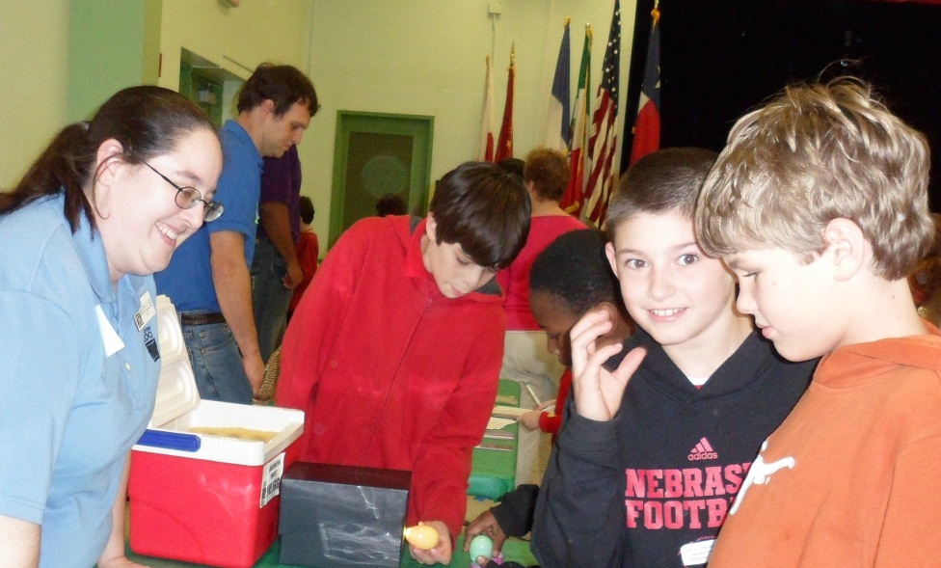

There are further items that will be added to the Attwater’s Prairie Chicken kit including:

* A chick life cycle exploration kit, a set of eggs with the different embryonic stages
* A domestic chicken replica skull
* Window decals and bracelets to sell
* APC tattoos

The life cycle exploration kit is something that both kids and adults will be fascinated by. They will be able to see how the chick develops as it grows in the egg. The skull, while not an APC, will portray the approximate size, shape, etc. of the birds. The decals and bracelets will benefit the Adopt an APC program, a fund run by Texas Parks and Wildlife. These items will be an affordable way for anyone to help with the recovery efforts. These items will also create a relationship between that individual and the APC program; furthermore, other people will ask them about these items and they will spread the word about these birds and why they are important. The temporary tattoos are another fun way to engage children and help them remember what they have learned. Kids will often show off their tattoo and tell people about the birds, also spreading the message to even more people.

With the determination of the Conservation Department and generosity from our Graphics Department, I was able to create an informative banner display to go along with the travel kit. This banner is compact, lightweight, and best of all; it is visually striking and informative when displayed. It appeals to Texans to show their pride and come to the aid of a native animal in need.

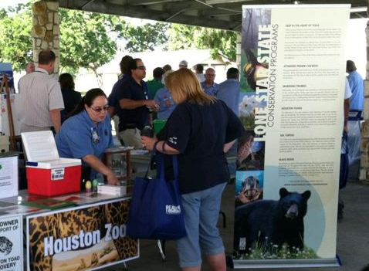

Not only was an improved display needed to gain support for the Attwater’s Prairie Chicken, but we needed to better utilize the social media tools at our disposal. Throughout the season, I wrote several blogs, we posted 3 to 4 times a week on Facebook, and we created a time-lapse video of chicks hatching for the Houston Zoo’s YouTube channel. The zoo Development team also created a donation campaign in the spring where the public could pay $50 to name a chick. These social media strategies produced a more informed public awareness about the Attwater’s Prairie Chickens.

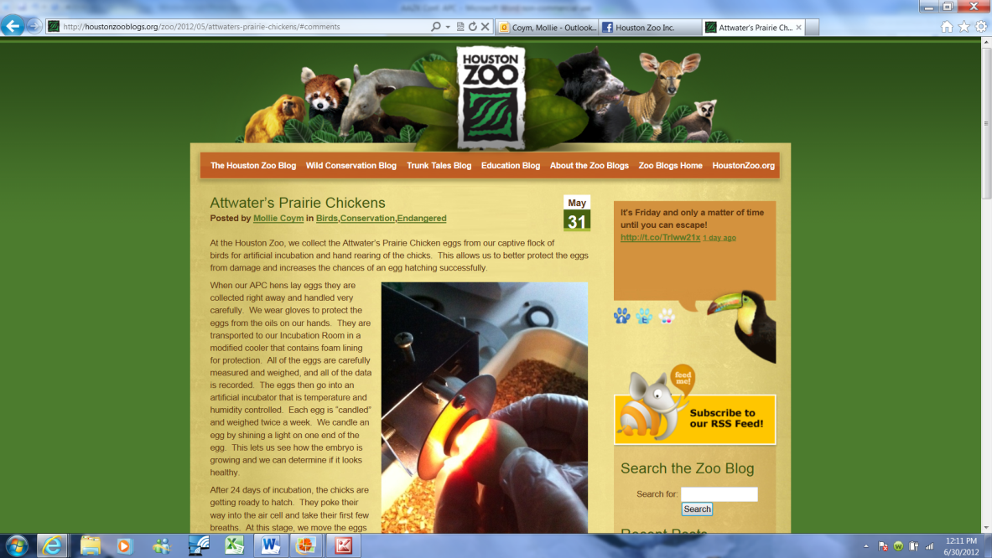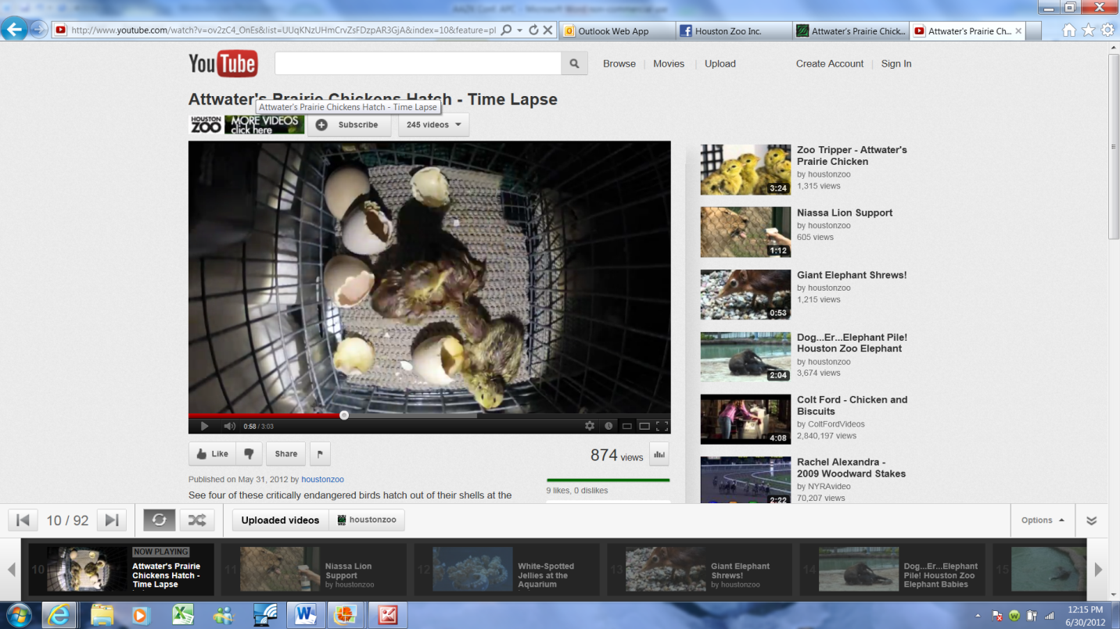

**Conclusion**

The new travel kit has already been utilized several times in 2012 at a variety of events including a school fair, the Environmental Fair for NASA employees, and at lecture series presentation at the Houston Zoo. At each of these events, members of the public were more inclined to visit the display and listen to the plight of the Attwater’s Prairie Chicken. The interactive components generated an interest in this species and seemed to create more of an attachment to these birds. With the support and assistance from our Interactive Marketing, Graphics, and Conservation teams, the Attwater’s have become one of the most followed and liked topics posted by the Houston Zoo and associated pages in 2012. With all of these strategies put together, we have created a successful new marketing campaign for the Attwater’s Prairie Chickens and generated a large new following with a fondness for this native in need. This is a crucial component for the continuation of captive breeding within the zoos and land preservation in Texas for future Attwater’s Prairie Chicken habitat.

**References:**

Bergan J, Morrow M, Rossignol T. 2010. Attwater’s Prairie Chicken Recovery Plan, 2nd Revision [Internet]. Albequergue (NM): U.S. Fish and Wildlife Service. Available from: <http://www.fws.gov.southwest/docs/APCRecoveryPlanSecondRev.pdf>

Hampp A. 2006. Animal Attraction: Marketing at the Zoo. Advertising Age [Internet]. 2006 Oct 30. 77 (44): 16. Available from: <http://ehis.ebscohost.com.mutex.gmu.edu/ehost/detail?vid=5&hid=23&sid=64a1baca-21cc-442a-b614-dec1b1f6948c%40sessionmgr11&bdata=JnNpdGU9ZWhvc3QtbGl2ZQ%3d%3d#db=a9h&AN=22976497>

Jurries RW. 1979. Attwater’s Prairie Chicken. Austin (TX): Texas Parks and Wildlife Department.

Lehmann VW, Mauermann RG. 1963. Status of Attwater’s Prairie Chicken. The Journal of Wildlife Management [Internet]. 27(4):712-725. Available from: <http://www.jstor.org.mutex.gmu.edu/stable/3798487?&Search=yes&term=chicken&term=status&term=attwater%27s&term=prairie&list=hide&searchUri=%2Faction%2FdoBasicSearch%3FQuery%3Dstatus%2Bof%2Battwater%2527s%2Bprairie%2Bchicken%26wc%3Don%26acc%3Don&item=5&ttl=142&returnArticleService=showFullText>

Morrow ME, Adamcik RS, Friday JD, McKinney LB. 1996. Factors Affecting Attwater’s Prairie-Chicken Decline on the Attwater Prairie Chicken National Wildlife Refuge. Wildlife Society Bulletin [Internet]. 24(4):593-601. Available from: <http://www.jstor.org.mutex.gmu.edu/stable/3783146?&Search=yes&term=Factors&term=Chicken&term=Prairie&term=decline&term=prairie-chicken&term=Attwater%27s&term=Attwater&term=affecting&term=National&list=hide&searchUri=%2Faction%2FdoAdvancedSearch%3Fq0%3DFactors%2Baffecting%2BAttwater%25E2%2580%2599s%2Bprairie-chicken%2Bdecline%2Bon%2Bthe%2BAttwater%2BPrairie%2BChicken%2BNational%26f0%3Dall%26c1%3DAND%26q1%3D%26f1%3Dall%26acc%3Don%26wc%3Don%26Search%3DSearch%26sd%3D%26ed%3D%26la%3D%26jo%3D&item=2&ttl=42&returnArticleService=showFullText>

Morrow ME, Rossignol TA, Silvy NJ. 2004. Federal Listing of Prairie Grouse: Lessons from the Attwater’s Prairie-Chicken. Wildlife Society Bulletin [Internet]. 32(1):112-118. Available from: <http://www.jstor.org.mutex.gmu.edu/stable/3784547?seq=1&Search=yes&term=chicken&term=status&term=attwater%27s&term=prairie&list=hide&searchUri=%2Faction%2FdoBasicSearch%3FQuery%3Dstatus%2Bof%2Battwater%2527s%2Bprairie%2Bchicken%26wc%3Don%26acc%3Don&item=1&ttl=142&returnArticleService=showFullText&resultsServiceName=null>

Silvy NJ, Hagen CA. 2004. Introduction: Management of Imperiled Prairie Grouse Species and Their Habitat. Wildlife Society Bulletin [Internet]. 32(1):2-5. Available from: <http://www.jstor.org.mutex.gmu.edu/stable/3784537?&Search=yes&term=%22Nova+J.+Silvy%22&list=hide&searchUri=%2Faction%2FdoBasicResults%3Fhp%3D25%26la%3D%26wc%3Don%26acc%3Don%26gw%3Djtx%26jcpsi%3D1%26artsi%3D1%26Query%3Dau%253A%2522Nova%2BJ.%2BSilvy%2522%26sbq%3Dau%253A%2522Nova%2BJ.%2BSilvy%2522%26si%3D76%26jtxsi%3D76&item=83&ttl=83&returnArticleService=showFullText>