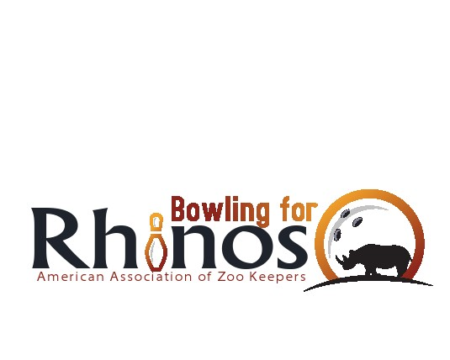
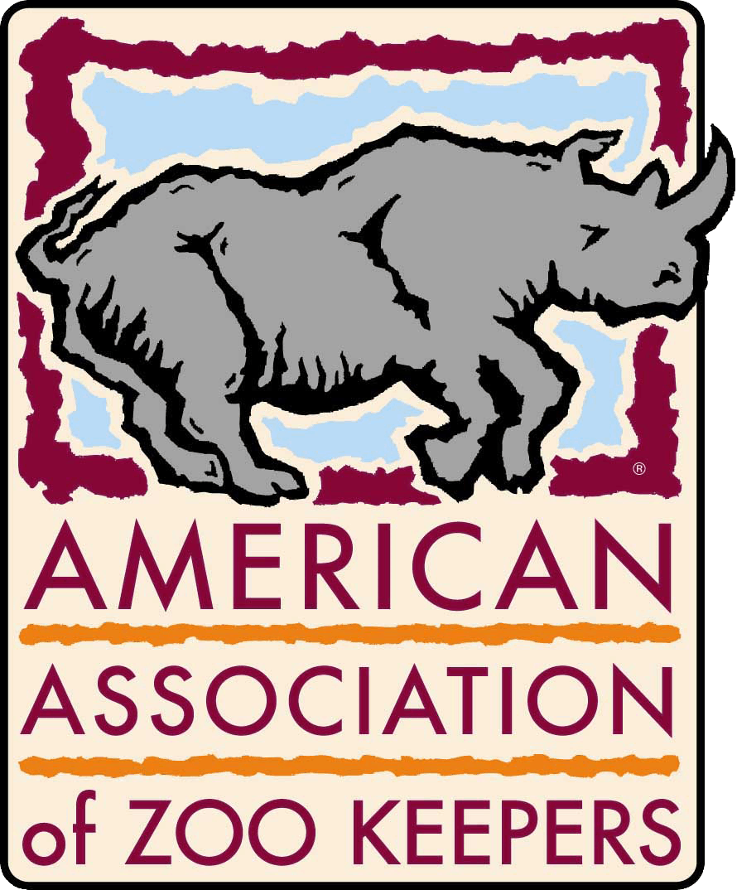
Holding a Bowling for Rhinos Event

Fund-Raising
Fund-raising takes on many facets. The conventional one used for Bowling for Rhinos is Bowling! Tips and advice for organizing a bowling event are listed in the following paragraphs. However, you may choose to have "Recycling for Rhinos" where you gather recycling and donate the total raised each year. Or in "Rocking for Rhinos", "Rummage for Rhinos", "Running for Rhinos", "Rapping for Rhinos" where you organize your fundraising in a completely different manner than what is explained below.

BFR Getting Started
In order to have a bowl-a-thon, all one needs is sponsor sheets, a financial form and a group of enthusiastic bowlers. It's that simple to start out small and every dollar counts. Contact a bowling alley to find a good date and let them know about the fund-raiser. The proprietor may offer anything from a free event hosting to free lane rental in exchange for shoe rental. Advertise the cost to bowl when they get their sponsor sheets. You can then either add a flat donation fee above any bowling rates or let the bowlers collect sponsors. It’s a good idea to create and distribute a rule sheet so the bowlers know who to make checks out to, when to hand in money, etc.

Planning for a Larger BFR Event
A Bowling for Rhinos event can get bigger and more complex from there. For a big event, plan 4-6 months ahead. Form a committee (even if it ends up consisting of only 1 or 2 people), contact a bowling alley for the best deal and set your date. This will allow ample time for your event to get in newsletters, calendars, and media. Find some local talent to volunteer to do the artwork for a T-shirt. T-shirts are free advertising and education, and most fund-raisers usually give T-shirts to the participants. Keep your list of names and addresses from the sponsor sheets of previous years to invite them again. If your event is on a weekend, you will probably realize greater public involvement.
Decide if you want to package a deal for your bowlers that covers the cost of bowling, a donation and maybe a T-shirt and/or meal. This is the most popular method of fundraising. Have bowlers turn in their money and sponsor sheets the night of your event. Have a few people to work the registration table so the event runs smoothly. Write letters or call local restaurants, movie theaters, and hotels to see if they could donate prizes for your event. These can be raffled or auctioned (check local regulations on raffles or auctions) in a silent auction, given as door prizes or awards for different categories like high and low scorers and this makes the event more exciting. Invite local celebrities from radio and TV stations. After the Event, write thank you letters for prizes and celebrity attendance.

Expenses
Prominently advertise that 100% of all event profits go towards conservation. All profits from the event are submitted to AAZK Bowling for Rhinos. Event holders will cover any expenses for this event by charging a set fee for bowlers to cover all fees charged by the Bowling facility (lane rental, shoe rental) and anything else the event holder provides (shirts, food, etc.) On top of the fee to cover expenses you can then build in a flat donation (preferred) or ask bowlers to obtain sponsors. Silent Auctions, raffles or sale of merchandise are pure profit.

BFR Fees
Bowlers collecting sponsorships will need to collect the money before the bowling date because the money is collected evening of the event. Donations above the bowling fees are tax deductible Event holders should offer bowlers receipts for their donations, again specifying only that donations above fees are tax deductible.

Event T-shirts
An excellent opportunity to raise additional money is the creation of a BFR Event T-shirt. They can be given away to bowlers in the fee package and/or sold separately. Create a design (an artist friend, volunteer, etc. is helpful at this stage) in .jpg or .eps file. Locate a local T-shirt company and negotiate a fair price – mentioning the BFR event is a worldwide conservation fund raiser. Try to negotiate a free or reduced price in exchange for logo placement on the shirt. Other local sponsors of your event can be added to the shirt

BFR Fund-raising Guidelines
- Events should be held from March 1 to 31 October
- All profits from the Event are due to AAZK by 1 December
- BFR Event holders should register their events with AAZK – contact Patty Pearthree – Program Manager for AAZK’s Bowling for Rhinos at Patty.Pearthree@aazk.org. AAZK advertises your event date in multiple media sources. Sponsor sheets can be ordered at this time.
- New Event holders can ask for an information packet and receive sponsor sheets.
- A $25 administrative fee to cover administrative and baking fees is require for every event Check can be made out to "AAZK – BFR Registration Fee" and mailed to:
AAZK
8476 E. Speedway Blvd. Suite 204
Tucson, AZ 85710-1728
First time Event Holders are exempt from the BFR Registration Fee.
- Form a BFR committee
- Locate a bowling alley (food supply and t-shirt company if going big)
- Advertise your event in calendars, fliers, etc.
- Solicit for prizes
- Contact Patty Pearthree if the information packet does not answer your questions (919-678-0449)
- To be eligible to win the Africa trip all funds must be submitted by September 1st!
There are two steps to completing the financial obligation
- Make out one check payable to "AAZK-Bowling For Rhinos" and send to:
AAZK
8476 E. Speedway Blvd. Suite 204
Tucson, AZ 85710-1728
(520) 298-9888
Ed.Hansen@aazk.org

- Send a copy of your financial form and a copy of only the high money raiser's sponsor sheets to:
Patty Pearthree c/o Bowling for Rhinos
318 Montibello Dr. Cary, NC 27513
(919) 678-0449
patty.pearthree@aazk.org

BFR Fundraising Tips for Success
- Set a date early so that it can be advertised in as many newsletters, fliers as possible. Info should be placed in zoo newsletters, zoo volunteer newsletters, zoo society commmunications, zoo maps or fliers, etc.
- Check with your Chamber of Commerce prior to setting date to find out events that could conflict. Once you choose the date, inform your Chamber of commerce.
- Talk to your zoo volunteers at an organized luncheon to let them know they can join the event or sponsor someone (have your forms ready).
- Put registration fliers in an area where volunteers may see them-in their reporting area
- Talk to your Zoo Society or other organization that monetarily assists the zoo
- Collect door prizes or Auction (raffle) items 4-6 months in advance in person with letter of donation request in hand and acknowledge any donation in writing.
- Send out invites to previous bowlers (addresses listed on sponsor forms from prior year)
- Look for “Rhino-centric” companies in your community and ask for donations and solicit them to participate in bowling.
- Advertise that your event is open to the public
- Seek help from your facilities Special Events and Graphic departments, graphics, etc. to market your Event.
- Advertise the list of prizes when soliciting bowlers for the Event.
- INVITE LOCAL CELEBRITIES to bowl at your event (especially TV/radio- free advertising)
- With permission from your facility post info next to rhino/elephant exhibits about your upcoming event and how to join!
- If you are going for the Africa Trip, let potential sponsor know they could help you win the prize!
- Send out communication to friends and family seeking donations. – they can donate on the web (aazk.org) and credit the donation to an individual or event.
- Log on to the AAZK web page (aazk.org) as an AAZK Member and take advantage of the promotional video posted on the BFR Resources page.
- There is a multimedia BFR CD for any participating chapter or institution that requests a copy. This CD includes the above videos, BFR PPT presentation w/ script. Contact Patty Pearthree at: patty.pearthree@aazk.org or 919-678-0449.

Other Helpful Ideas
If bowling doesn't seem to work in your area, try “Wi Bowling for Rhinos”, "Rock n' for Rhinos", "Rummage For Rhinos", Run For Rhinos, Cueing For Rhinos or Recycling for Rhinos (or create a new idea). Some chapters even donate money to BFR without holding an event. All goes to help conservation worldwide under AAZK’s Bowling for Rhinos Program!
Print an information sheet about BFR, the sanctuaries that donations are tax-deductible, tips for collecting, etc. to give out to any potential bowlers. Print up a flier with a registration form about your event and with facility permission, place it in zoo maps, zoo restaurants and post at community libraries and schools, etc.
Remember, anyone can join the Bowl-a-thon so don't limit yourselves to only zoo people. However, be sure it is clear that only National AAZK members are allowed to win the trip. If you have a potential winner, ask them to join AAZK.

Matching Gifts
Many of your bowlers work at corporations which have matching gift programs. This means that when they donate to BFR, the company they work for will match their gift to BFR. This is a very simple program and can double your money with little effort. Follow these steps:
- When someone pledges or donates to BFR, ask if they are employed by a company with a matching gift program?
- If they don't know, they can find out by asking their Human Resources or Financial office.
- They can obtain a matching gift form from their personnel office and complete it.
- Send the completed form to Patty Pearthree and AAZK will do the rest!
AAZK Chapters or facilities, no matter how large or small should hold a Bowling for Rhinos event. AAZK is here to provide any assistance you need to make your Event successful.

