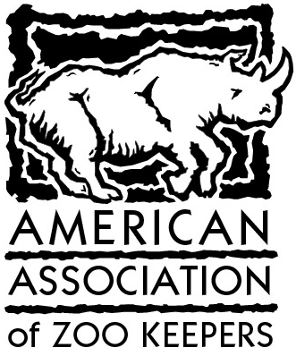
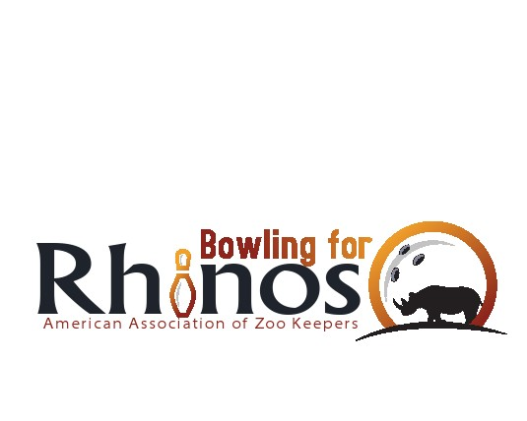
Bowling For Rhinos
Official Sponsor Sheet
100% of all donations go directly to conservation!

Bowlers: Bring this form and all donations with
you the night of your event. Keep a copy for your records.

Name: __________________________________________________
Address: ________________________________________________
City, State, Zip: ___________________________________________
Phone, Day: ___________________ Night: _____________________
Zoo or Institution: _________________________________________
Make checks payable to: ____________________________________

Sponsor’s Name | Address/Phone | Amount Pledged | Check  No. | Receipt  No. | Rec’vd
Totals
I understand that by participating in this fundraiser, I will in no way hold the American Association of Zoo Keepers Inc., Blue Rhino Inc., the local institution, or bowling lanes responsible for any injury, accident or damages sustained while participating in this event.
** Participants under the age of 18 must have this form signed by parent or guardian.
Signature: ______________________________ Date: ____________

