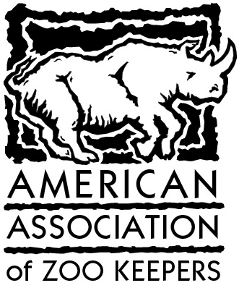
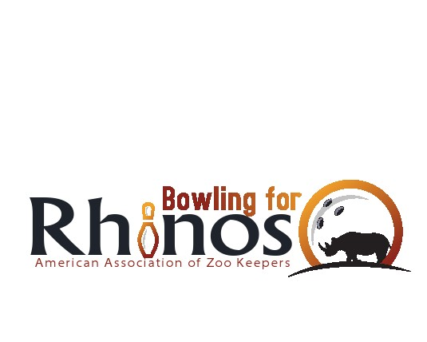
Bowling For Rhinos
Official Sponsor Sheet
100% of all donations go directly to conservation!

Bowlers: Bring this form and all donations with
you the night of your event. Keep a copy for your records.

Name: __________________________________________________
Address: ________________________________________________
City, State, Zip: ___________________________________________
Phone, Day: ___________________ Night: _____________________
Zoo or Institution: _________________________________________
Make checks payable to: ____________________________________

Sponsor’s Name | Address/Phone | Amount Pledged | Check  No. | Receipt  No. | Rec’vd
Totals
I understand that by participating in this fundraiser, I will in no way hold the American Association of Zoo Keepers Inc., the local AAZK Chapter/institution, or bowling lanes responsible for any injury, accident or damages sustained while participating in this event.
** Participants under the age of 18 must have this form signed by parent or guardian.
Signature: ______________________________ Date: ____________

