2016 Conservation Committee Member Handbook
Dear Conservation Committee Member,
Welcome to the AAZK Conservation Committee!
Your commitment to this committee places you in the company of other committed animal care professionals with a special interest and background in conservation. As a member of this committee, your work will have a very profound effect on our profession, other keepers and the animals for which we care. This committee is dedicated to promoting conservation efforts that AAZK members are involved with, in addition to connecting keepers with conservation opportunities. The work demands of the committee can be great but the personal rewards are even greater.

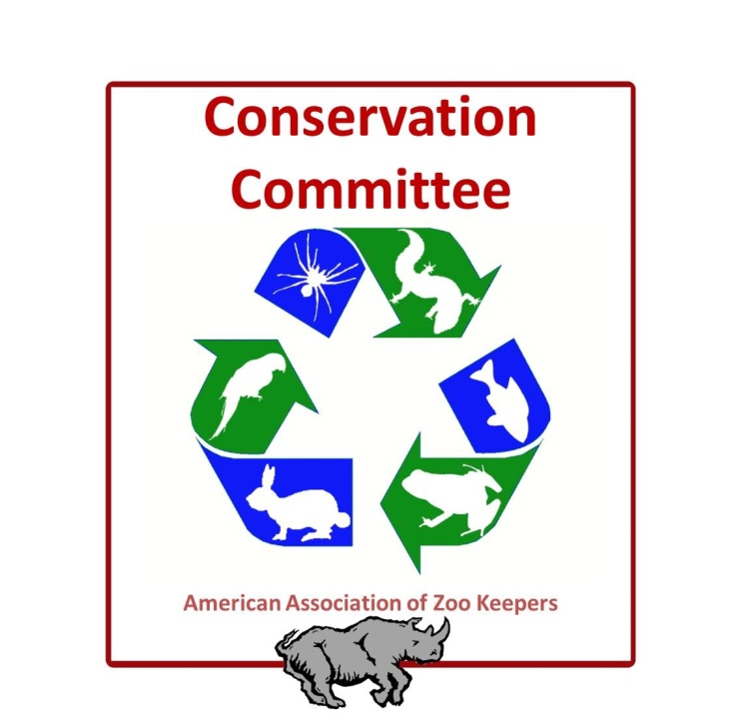
We look forward to working with you in fulfilling our mission advancing excellence in the animal care profession.

Sincerely,
Christy Poelker, Chair
Janee Zakoren, Vice-Chair
AAZK Conservation Committee
The American Association of Zoo Keepers

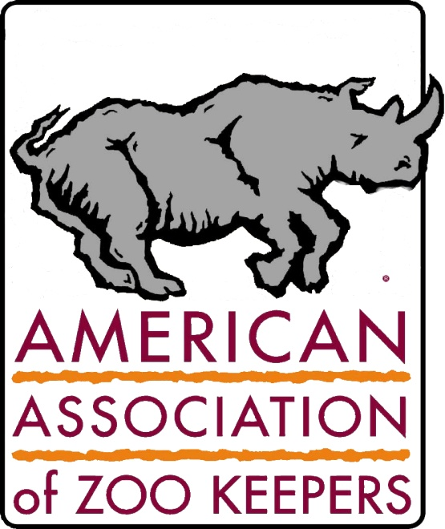
Mary Ann Cisneros
Board Oversight
The American Association of Zoo Keepers
maryann.cisneros@aazk.org

Penny Jolly
President
The American Association of Zoo Keepers
Penny.jolly@aazk.org

Conservation Committee Member Handbook 2016

Section 1: Member Criteria & Membership

Committee Member & Advisor Selection Criteria:
The Chairs of the AAZK Conservation Committee and Board Oversight appoint all committee members and advisors for the Conservation Committee. The Conservation Committee Chairs may review applicants and make recommendations to the Board of Directors, but the appointments are under the complete discretion of the Committee Chairs, with input from the Board Oversight.

Selection criteria for new committee members include:
- Demonstrated interest in serving by responding to email correspondence in a timely fashion and offering feedback, sharing time and talents, and engaging in committee activities
- Commitment to active participation by serving on at least one project team
- Willingness and ability to attend monthly online committee meetings at least six times a year
- Willingness and ability to attend yearly conferences at least once every four years
- Leadership in the field or expertise in an area that the committee leadership has identified as being needed to accomplish the goals of the CC
- Diversity in the composition of committee membership: geographic, aquarium/zoo, size of organization, tenure in the profession, areas of expertise
- Enthusiasm for enhancing CC mission for zoo and aquarium professionals

Section 2: Conservation Committee Member Expectations & Duties

Charge of the Committee:
The Conservation Committee is composed of members and advisors whose goal is to:
- Serve our AAZK members by providing access to up to date resources relevant to conservation.
- Strive to encourage, educate, and share knowledge about conservation
- Oversee the development of conservation related activities at the annual conference, including, by not limited to, the Bowling for Rhinos rally
- Provide opportunities for AAZK members to share conservation related experiences in articles submitted for publication in our column “Conservation Station”
- Seek out experts and new research related to conservation and find ways to disseminate that information among AAZK membership.
- Use social media to promote conservation activities and news
- Recognize exceptional efforts in conservation by selecting the recipient of the Nico van Strien Conservation Award announced at the annual conference
- Support AAZK chapters in raising funds and awareness about the conservation of rhinos and their habitats
- Provide guidance on hosting an environmentally friendly conference to the hosting chapter and delegates of the annual conference
- Contribute to the mission of the Trees for You and Me campaign
- Maintain and update a database of conservation opportunities available to the membership
- Track donations from AAZK chapters to conservation organizations
- Serve as a liaison between AAZK Conservation Partners and the membership by providing information, updates and news

Committee work is primarily accomplished through on-line committee meetings, email correspondence, and conference calls.

Reports to: Ultimately, the Conservation Committee reports to the AAZK Board of Directors through the CC Committee Chairs and Board Oversight.

Committee Member Terms:
Longevity and experience are important factors in maintaining continuity in the Conservation Committee. However, we recognize that work and outside responsibilities may dictate how much time a committee member may commit to the Conservation Committee. Because we have no set limit for the length of commitment for committee members, we ask that you self-regulate your life-work balance in a positive manner. Each committee member’s fulfillment of the duties and terms listed in this document will be evaluated yearly by the chair s& board oversight. If commitments and/or expectations are not met then the board will discuss ramifications of nonfulfillment, which may include dismissal from the Conservation Committee. Under special circumstances Conservation Committee members that have actively served a minimum of 3 years can ask to take a 1-year leave of absence due to personal circumstances that may limit their ability to contribute for a window of time.

Committee Member Duties:
- Actively participate in the work of the committee, working to fulfill AAZK and committee goals
- Focus on the best interests of AAZK and the Conservation Committee rather than on personal or constituent interests
- Participate in monthly committee on-line meeting or conference calls (attend at minimum of six committee meetings per year but more is encouraged)
- Complete tasks and respond to committee communication according to established guidelines and timelines
- Cast votes on motions presented during committee meetings or via email
- Serve as point person or co-point person on at least on project team
- Support decisions of the committee
- Provide updates to the Conservation Committee leadership regarding the progress of assigned initiatives
- Provide timely comments and input as requested (Conservation Committee Annual and Mid Year Report, etc.)
- Support Conservation Committee social media activities.
- Support the activities of all Conservation Committee project teams
- Keep up to date on all Conservation Committee communications.

Committee Advisor Terms:
Advisors to the committee are appointed on an as needed basis. AAZK recommends that advisors be evaluated at least every two years as to the level of their participation, and in view of the potential need to represent different interest groups, disciplines, geographic areas, etc., in an advisory capacity, depending on the focus of the committee and the composition of the Conservation Committee membership itself. Advisors unable to make a commitment may be asked to step down.

Advisor Duties:
Attend at least three online committee meetings per year
Serve on one or more of the committee project teams
Provide timely comments and input as requested
Respond to requests for information or ideas in a timely manner
Be a leader (present at national meetings, teach classes, publish in peer reviewed journals) in topics related to conservation.

Project Point Persons:
Project Point Persons are assigned by the Chairs, with the opportunity for input on such assignments from committee members. In addition to the regular committee member duties, Project Point Persons are expected to:
- Facilitate phone or online meetings with project team members in addition to monthly full committee conference calls or online meetings
- Communicate with project team members via email and/or phone about project tasks and deadlines
- Communicate with the Chairs about project progress and provide monthly updates during all committee conference calls or online meetings
- Establish goals and timelines for projects
- Drive project activities and fulfill project goals.
- Communicate with the Chairs about project progress for the annual and mid-year committee reports

The Leadership Team will evaluate member/advisor participation based on the cited criteria on an annual basis and make appropriate recommendations to the incoming president.

Committee Leadership – The Executive Team:
The Executive Team of the Conservation Committee is comprised of two Chairs and the Board Oversight to the Committee.

Committee Chair Duties:
- Report to the AAZK Board of Director Oversight
- With the Board Oversight, develop a work plan that will allow the committee to effectively discharge its responsibilities over the course of the year
- Ensures that the work of the committee is carried out between meetings with the full support of AAZK Leadership team and Board of Directors
- Ensure that committee work supports the current Board approved long range and strategic plans
- Facilitate monthly conference calls or online meetings
- Approve committee meeting minutes prior to distribution
- Communicate with AAZK Board prior to each Board Meeting, including drafting and submitting reports of activities to the Board (after gathering input from committee members)
- Compile information from other committee team members
- Develop agenda and facilitates annual and midyear committee reports
- Inform prospective committee members of performance expectations prior to nomination and appointment
- Assign new members to projects as needed
- Review individual committee member participation and performance and offer feedback

AAZK Board Oversight Duties:
- Represent the Conservation Committee at AAZK Board of Director meetings
- Assist the Conservation Committee Chairs in preparing and distributing correspondence such as agendas, meeting minutes, conference call minutes, and Board Reports as well as communicating to AAZK Board Members, and others as appropriate.
- Track financial information and provide a report to the committee at least twice a year
- Report to the committee on decisions of the Board of Directors, Executive Team or other AAZK committees that impact the Conservation Committee’s activities
- With the Board Oversight and Conservation Committee Chairs, provide input to the AAZK Board Chair and Chair-Elect regarding potential Conservation Committee members and chairs
- Communicate relevant Board discussions and decisions to the Conservation Committee
- Serve as a go-between and communication conduit for the committee with the Board and AAZK Executive team
- Assist with formulating strategic Conservation Committee initiatives
- Participate in annual and midyear meetings as well as committee meetings as available
- Advise on and review Conservation Committee communications with the AAZK Board of Directors, primarily regular committee reports, in advance of submissions

Section 3: Committee Projects

The Conservation Committee is charged with serving AAZK members by providing access to up to date resources relevant to conservation topics. The committee strives to encourage, educate, and share knowledge about green practices and conservation activities. To support this priority for AAZK, the Conservation Committee organizes its work around the following project:
- Conference Participation
- Bowling for Rhinos Rally
- Social Media Presence
- Bowling for Rhinos Support
- Conservation Opportunity Database
- Conservation Station Column
- Nico van Strien Conservation Award
- Green Conference Guidelines
- Trees for You and Me Support
- Chapter Conservation Donation Database

Specific assignments and goals for each of these Projects are outlined in Appendix B.

Appendix A: Current List of CC Members/Advisors and Contact Information
Appendix B: Projects

