**Fecal Firming in a Female Chimpanzee, *Pan troglodytes***

***Alissa Fuhrman***

*Houston Zoo, 1513 Cambridge, Houston TX 77030,*

*afuhrman@houstonzoo.org*

**Introduction:**

The Houston Zoo is home to ten chimpanzees, *Pan troglodytes.* The group consists of five males and five females, aged 8 to 40. One of the females, Maizey, has a history of consistently loose stool. Her feces have been repeatedly tested for parasites, and all tests have come up negative. The veterinary staff has determined that the consistency of her stool does not warrant prescription drugs at this time. In addition to loose stool, Maizey has a very large estrous swelling, upon which the feces stick. Though not a medical concern, this became a keeper concern since it may be a source of discomfort for the animal, and is also unsightly for guests. Keepers decided to pursue a ‘home remedy’ trial to see if any dietary changes could firm her stool, and allow it to fall rather than stick. Data was taken once a day, noting consistency, color, food bits present, flatulence and the fecal consistency in the rest of the group. Also noted were all items fed to the group that day. The dietary changes were tried for a month long phase for each change, with one month of her normal diet spaced between phases. The different dietary changes included removing yogurt, adding papaya, banana, and psyllium wafers. Additions were given once or twice daily depending on the item. This paper will present the outcome of each trial.

**Background**

Chimpanzees, *Pan troglodytes,* originate from Africa. Chimpanzee habitat ranges from tropical rainforest and extends to forest-savannah as well as montane forest up to 3000 meters (Meester and Setzer 1977). Weights of chimpanzees in captivity are up to 80 kg for males and 68 kg for females (Nowak 1999), whereas weights in the wild are 34-70 kg for males and 26-50 kg for females (Junger and Susman 1984). The diet of chimpanzees is omnivorous, including fruits, seeds, plant matter, honey, insects, eggs and meat, though food intake does vary by season (Van lawick-Goodall 1968, Bateman 1984). Feeding occurs for 6-8 hours during the daytime, and the chimpanzees will travel distances from 1.5-15.0 km while foraging (Van lawick-Goodall 1968). Captive chimpanzee diets also have commercially prepared chow which has the necessary protein; though their diet is probably lower in carbohydrates and fiber than the wild diet (Pruetz and McGrew 2001). The female chimpanzee estrous cycle lasts for 36 days, in which the female is receptive for 6-7 days when her estrous swelling is largest (Van lawick-Goodall 1968).

Pinworms are the most frequent cause of gastrointestinal illness in captive chimpanzees (Keeling and McClure 1974). The next most frequently occurring digestive illness in chimpanzees is non-specific diarrhea of an unknown origin (Lee and Guhad 2001). In these cases, no infectious or metabolic causes can be found (Lee and Guhad 2001). Some possibilities could be psychological stress or dietary issues. There have been cases of diarrhea associated with the female estrous swelling (Lee and Guhad 2001). Most often this transient diarrhea is of no consequence (Lee and Guhad 2001).

Maizey was born on February 14, 1986. She came to the zoo on July 14, 2010. Prior to her transfer to our zoo she was quite overweight at 94.5 kg. Over the last two years we have gotten her weight down to around 71kg, though she is still overweight. She even weighs more than our dominant male. One of the more dominant female chimpanzees in our group, Maizey can be food aggressive, which would make restricting her food nearly impossible without isolating her or limiting the rest of the group as well. When she first came to us, we were told that she has always had slightly loose and messy stools, but that it had never turned into anything worse, which is still the case now. Her feces have been routinely checked for parasites, specifically nematodes, including pinworms and trichinosis, and flagellates, which include protozoa like giardia, and balantidium. The tests have always come back negative for parasites.

The chimpanzee diet at the zoo consists of commercially processed Mazuri brand primate biscuits, fruits, vegetables, lettuce and forage foods. Each day, two fruits are given on a rotating schedule. The fruit selection might be banana, apple, pear, blueberry, cantaloupe, strawberry, or grapes. The vegetables are also rotated, and each day they get two different vegetables including: peas, corn, carrot, sweet potato, green beans, broccoli, onion, or tomato. They also get a weekly rotational item which could be anything, including but not limited to: mango, papaya, coconut, pumpkin, watermelon, pineapple, kiwi, honeydew melon, orange, pomegranate, garlic, grapefruit and sugar cane. The lettuce type is also rotated. Typically we offer one per day of romaine, red leaf lettuce, green leaf lettuce, cabbage, red cabbage, bok choy, kale or endive. The primates get a different forage food daily including: mixed nuts, applesauce, popcorn, oats, currants, figs, peanuts or sunflower seeds. They also receive 2 hard boiled chicken eggs per animal once a week.

**Methods**

Because diarrhea can be classified many ways and with all parasitic tests negative, we started to analyze the feces. With observation, we hoped to be able to identify if the loose stool originated in the small intestine or in the large intestine. The determination of diarrhea as small or large intestinally based would narrow down remedy options. Using information from the Textbook of Veterinary Internal Medicine (See Table 1), we created a form for the keepers to track daily fecal observations of Maizey’s output. Visually, keepers were to rate the consistency of Maizey’s poop, the presence of undigested food, increased occurrences of flatulence, fecal color, the range of consistency for the rest of the group and all of the food the chimpanzees were fed that day (See Table 2).

The feces were numerically coded, and the keepers had access to a pictorial guideline for a consistent rating. The codes ranged from 1 to 6; the lower the number was the firmer the stools. A score of 1 was hard and pelleted, and a score of 6 was entirely liquid. The rating of 2 - 3 was ideal for the chimpanzees. Maizey’s feces were typically scored a rating of 4 or 5.

The presence of undigested food in the feces would help us identify the problem in two ways. Undigested food indicates small intestinal issues. It also helps us determine how long food takes to travel through the digestive tract, which could help pinpoint any dietary effects on her stools. Increased flatulence could also mean a small intestinal disorder. Another symptom of small intestinal diarrhea is variable stool color. The fecal consistency of the rest of the group was also noted in order to be able to rule out days where the entire group had fecal issues, as that could potentially skew the results.

There are several symptoms that differentiate diarrhea from the small or large intestines that would be difficult, if not impossible, for keepers to evaluate. These symptoms were not included in the data chart for that reason: tenesmus, urgency, and frequency. Vomiting and weight loss were also not included in the daily chart because those symptoms are so rare that it would have been written in her permanent records.

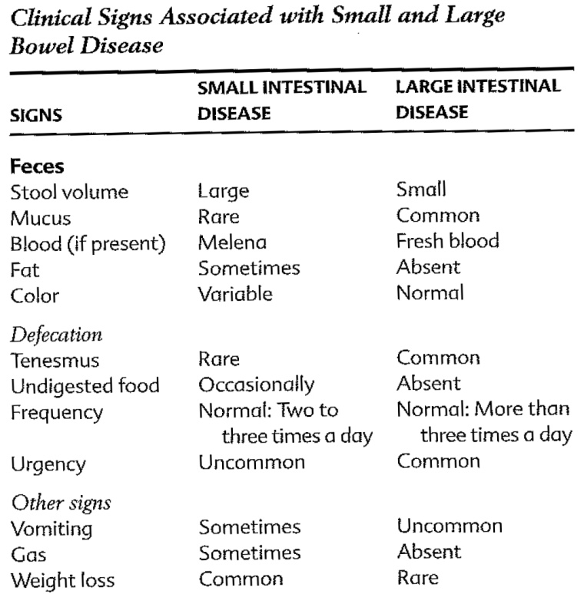

Table 1 Textbook of Veterinary Internal Medicine

|  |  |  |  |  |  |  |  |  |
| --- | --- | --- | --- | --- | --- | --- | --- | --- |
| Date | Maizey Poop | Undigested Food | Gas ( √ ) | Color | Yogurt ( √ ) | Group Poop | | Diet including - Produce, Greens, forage |
| 23-May | 5 | No |  | Brown | Yes | 2-4 | Cabbage, Red Cabbage, Banana, Grapes, Carrots, Cucumbers, Peanuts | |
| 24-May | 4 | No |  | Brown | Yes | 1-3 | Romaine, Apples, Pears, Peas, Corn | |
| 25-May | 4 | No |  | Brown | Yes | 1-4 | Red Leaf, Blueberries, Cantaloupe, Sweet Potato, Broccoli | |
| 26-May | 4 | No |  | Brown | Yes | 2-4 | Bok Choy, Banana, Watermelon, Strawberry, Tomato, Broccoli | |
| 27-May | 4 | No |  | Brown | Yes | 2-5 | Romaine, Apple, Blueberry, Carrot, Sweet Potato, Red Onion | |

Table 2 - Sample of Daily Fecal Chart

**Remedies**

Chimpanzees and humans are thought to be closely related, with 98% of the same genetic makeup. The two species potentially have a common ancestor that lived approximately 4-8 million years ago (Website 1). Biologically, chimpanzees are more closely related to humans than they are to gorillas (Website 2). Due to this genetic relationship, it was thought that a trial of human home remedies would be worth trying for Maizey. The home remedies we used for this study were removing dairy, adding papaya, adding banana, and adding psyllium fiber.

The small intestine is responsible for causing lactose intolerance because it produces the enzyme needed to digest lactose. The treatment for this condition is to remove dairy from the diet (Website 3). The only dairy product that the chimpanzees receive in their diet is 2 tablespoons of yogurt each day for delivery of medicine. For the first part of our study we replaced yogurt with applesauce. After the dairy-free portion of the study, it was decided to keep using applesauce in the morning. Yogurt was added back in, and keepers noted on the chart if they used applesauce or yogurt in the diet that day.

Papaya has a protease enzyme called papain which helps the stomach break down protein molecules which aids in the absorption of the nutrients. Papain has many other therapeutic benefits as well. It can help regulate irritable bowel syndrome and ulcers with its anti-inflammatory properties. It also helps to dissolve fats, which helps with digestion. Papain has also been effective with relieving food allergies (Website 4). Maizey was not too fond of papaya. The original plan was for her to get one serving (100 grams) of papaya in the morning, and another in the evening. Since she was reluctant to take her papaya, both servings were combined and given in the morning. The papaya was blended with some juice and she drank it like a smoothie.

Bananas contain inulin, which is a starch called fructo-oligosaccharide, or FOS (Swanson et al 2002). FOS is considered a prebiotic because it cannot be digested by the host’s digestive system. They can only be broken down by the bacteria that live in the digestive tract. Eating food with prebiotics create a beneficial environment for probiotic bacteria by providing food for those bacteria (Website 5). Though prebiotics have not been proven to reliably help diarrhea, probiotic bacteria have been generally accepted as beneficial to a multitude of intestinal disorders (de Vrese and Marteau 2007). Maizey received two bananas in her diet per day; one in the morning, and one in the evening. She consumed the bananas without hesitation.

A general treatment for large intestinal diarrhea often includes a high fiber diet (Website 6). The high fiber supplement that we chose for Maizey was Metamucil Fiber Crisps. She received one serving twice a day. The serving size is two crisps, and must be taken with at least 8 fluid ounces of liquid. Maizey took the crisps without a problem, but sometimes did not want to drink all 8 ounces of fluid. The liquid we used was tea or diluted juice.

In the middle of the study, it was determined that Maizey should go on birth control for management purposes. The birth control that was used is a hormonal drug that controls ovulation. The drug name is Portia, and it contains the hormones ethinyl estradiol and levonorgestrel. This birth control also affects the estrous swelling, so that the female chimp no longer swells monthly. We did not change her diet for the first month of her birth control pills because of the possible effect that estrous may have on fecal consistency (Lee and Guhad 2001). We did keep monitoring her fecal output to determine if her swelling or her cycle had any effect.

**Results**

This study began on September 5, 2011 with the initial data collection. The first stage of research left the diet alone, and the keepers just noted fecal consistencies with the normal diet. We started with the control to see if there were already any trends between her food and feces. A control phase of a month of normal diet was also tracked in between each phase of dietary changes. The month long control between phases was added to be sure that any potential result from a previous stage would not give false effects in the data.

For the entire study, Maizey’s feces were rated as a 2 consistency only one time. The best her stools usually became was a level 3. For each stage of the study, the rating of 3 for her fecal consistency was tallied, and a percentage was calculated out of the rest of the results for that stage. The average of her consistency for the entire stage of was calculated as well. Any day where the entire group had a 5 or 6 rating for their fecal consistency was excluded.

|  |  |  |  |  |  |  |  |
| --- | --- | --- | --- | --- | --- | --- | --- |
| Phase Title | Date Begin | Stage length | Days of data | Days of good | Percent good | Poop Average | Difference from Control |
| Control 1 | 09/05/11 | 31 | 24 | 9 | 37.50% | 3.94 | -0.33 |
| No Dairy | 10/06/11 | 35 | 24 | 6 | 25.00% | 4.15 | -0.12 |
| Control 2 | 11/10/11 | 24 | 20 | 1 | 5.00% | 4.50 | 0.23 |
| Papaya | 12/04/11 | 59 | 34 | 3 | 8.82% | 4.35 | 0.08 |
| Control 3 | 02/01/12 | 25 | 11 | 0 | 0.00% | 4.73 | 0.46 |
| Birth control | 02/26/12 | 29 | 24 | 0 | 0.00% | 4.46 | 0.19 |
| Banana | 03/26/12 | 38 | 23 | 1 | 4.35% | 4.48 | 0.21 |
| control 4 | 05/03/12 | 33 | 24 | 4 | 16.67% | 4.21 | -0.06 |
| Metamucil | 06/05/12 | 31 | 27 | 2 | 7.41% | 4.31 | 0.04 |
| Combined controls | NA | 113 | 79 | 14 | 17.72% | **4.27** | 0.00 |
| Estrous 0-1 | NA | NA | 14 | 2 | 14.29% | 4.07 | -0.20 |
| Estrous 1 | NA | NA | 121 | 16 | 13.22% | 4.30 | 0.03 |
| Estrous 1-3 | NA | NA | 59 | 4 | 6.78% | 4.37 | 0.10 |
| Estrous 3-4 | NA | NA | 13 | 1 | 7.69% | 4.38 | 0.11 |
| Sweet Potato | NA | NA | 58 | 10 | 17.24% | 4.38 | 0.11 |
| Yogurt | NA | NA | 52 | 11 | 21.15% | 4.17 | -0.10 |
| Blueberries | NA | NA | 71 | 8 | 11.27% | 4.39 | 0.12 |
| Light Brown | NA | NA | 71 | 11 | 15.49% | 4.43 | 0.16 |
| Brown | NA | NA | 75 | 8 | 10.67% | 4.18 | -0.09 |
| Dark Brown | NA | NA | 5 | 0 | 0.00% | 4.50 | 0.23 |
| Greenish Brown | NA | NA | 1 | 0 | 0.00% | 5.00 | 0.73 |
| Entire Study | 09/05/11 | 305 | 211 | 26 | 12.32% | 4.32 | 0.05 |

**Table 3 – Summarized Results of the Entire Study**

The initial control phase lasted for 31 days and the keepers were able to get data for 24 days, with the result of 9 days of stage 3 consistency. The percentage of ideal feces was 37.50% for the first control stage. The average of the consistencies throughout that stage was 3.94, the difference for the control average is -0.33.

The dairy-free phase lasted for 35 days, of which we have 24 days of data, the average being 4.15. There were 6 good days which is 25.00%. The difference of this average from the combined control average is -0.12.

The second control phase lasted for 24 days, of which we have 20 days of data. The average consistency is 4.50. There was only 1 day of consistency level 3 which is 5.00%. The difference from the combined control average is 0.23.

The papaya stage lasted for 59 days, though it was not successfully taken by Maizey for the first 12 days. After the presentation was changed to a blended shake once a day, the stage lasted for 48 days, with 34 days of data. The average of the successful papaya part is 4.35. There were 3 days of good results, which is 8.82%. The difference from the combined control average is 0.08.

The third control phase lasted for 25 days with 11 days of data, though there were no days that had level 3 or better stools, which is 0%. The average for this stage was 4.73, which is a difference from the combined control average of 0.46.

At this time in the study, it was decided to put Maizey on birth control, so that became a stage in this process to allow for any hormonal change effects. The birth control stage lasted for 29 days, of which we have 24 days of data. The average was 4.46 for the stage and it has a difference of 0.169 from the combined control average. There were no days of good fecal results which is 0%.

It should be noted that after the dairy free stage, yogurt was not added back into her diet right away, and when it was, it was given periodically, alternating with applesauce, a column was added to the chart to ensure recording of which was given in April, during the banana phase. Prior to that, keepers did not differentiate between the two.

The banana stage lasted for 38 days, of which we have 26 days of data, though we had to exclude 3 days of data due to group digestive issues, which brings the calculable number of data days to 23 with an average for those days being 4.48. There was 1 day of good stool which is 4.35% for that stage. There was a difference of 0.21 between this stage average and the combined control average.

The fourth control phase lasted for 33 days, of which we had 24 days of data, and 4 days of good stool. The average was 4.21 and the percentage was 16.67%. The difference between this average and the combined control average is -0.06.

The Metamucil phase lasted for 31 days, of which we have 27 days of data; there were 2 days of good stools, which is good 7.41% of the time. The average consistency of this stage was 4.31, which is a difference from the combined control average of 0.04.

As well as individually, all of the control phases were calculated together. The entire control phases lasted for 113 days, of which we have 79 days of data. 14 of those days had good feces recorded, which is good 17.72% of the time. The average consistency for all of the controls is 4.27. This is the average used for comparison to the other stages in this study.

There were four fecal colors recorded during the study. It was indicated as light brown 74 times, brown 75 times, dark brown 5 times and greenish brown once.

The rest of the diet was analyzed as well. Before being able to analyze if her general diet had any effect on her fecal consistency, we had to identify how long the effect would be seen after she was fed. To do so, the food bits present in her feces were tabulated and compared to when that item was fed. There were 28 days recorded with food particles seen in feces. 19 times, that food was fed the day before, 6 times it was fed two days before, and 2 times it was three days before. (See Figure 1)

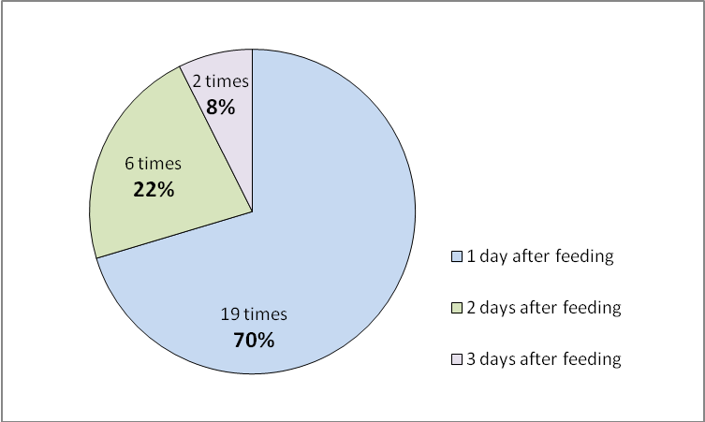

**Figure 1 - Food Particles Present in Feces related to Feeding times**

To determine if any of her normal diet had any effect on her output, we tabulated all of the days of level three or better consistency, and compared that to the diet she received the day before. The highest number of occurrences were examined and calculated back to how many times she received that food item throughout the study. The most common food items given prior to a good fecal were sweet potato, yogurt, and blueberries. Of the 22 total days of consistency 3 feces, Maizey received sweet potato before 10 of them. Sweet potato was recorded 58 times in her diet prior to any fecal recoding, which means we recorded that 17.24% of the time sweet potato was fed resulted in good stool. Yogurt was seen prior to 11 days of good stool, and it was recorded as given on 52 occasions in conjunction with a fecal observation, or 21.15% of the time. Blueberries were given 8 times before good stool, and recorded as given 71 times prior to any fecal observation, which is good 11.27% of the time.

Estrous was calculated daily during this study. The next set of calculations compares the fecal results solely based on her estrous swelling size. The Houston zoo rates estrous size on a 0-4 point scale. The averages and percentages were calculated for estrous swelling stages of less than 1, estrous size 1, estrous 1-3 and estrous 3-4. The reason for calculating ranges in this study is to account for human discrepancy.

Maizey had four full cycles before being placed on birth control. There were 13 days of data for a swelling size of higher than 3 during the study. The average rating of her feces for this period was a 4.38 and she had a 7.69% good stool while she was in full estrous. There is a difference of 0.11 between the average for this stage and the combined control average.

There were 59 days during the study that she had an estrous swelling higher than 1 and lower than 3 with fecal data. The average consistency was 4.37 during this time, and she had 4 days of good stools, or 6.78% of the time. There is a difference of 0.10 between the average for this stage and the combined control average

Maizey does not typically have an estrous swelling lower than 1, even during the low parts of her cycle. During this study, Maizey was recorded as having an estrous level of 1 for 121 days in which we also have fecal data. During those days, she has been recorded as having 16 days of good fecal ratings, which is 13.22% of the time. The rating consistency average is 4.30 which have a difference of 0.03 from the combined control average.

Occasionally, Maizey will exhibit a 0 sized estrous. During this study, there is fecal data in conjunction with a smaller than 1 estrous swelling for 14 days, 2 of which were good, or 14.29%. While she was a level 0-1, the average fecal consistency was 4.07. The difference of averages from this and the combined controls is -0.20.

To help gauge if there was any effect at all with any of our home remedies, the fecal consistencies were calculated for the entire study. Her average for the entire study was and out of 211 days of data she had 26 days of good stool, or 12.32% or the time. The average for the entire study is 4.32.

**Discussion**

Because the controls were so inconsistent (See figure 2) the method of data collection may be flawed. Even with a pictorial guide, there is the possibility of keeper subjectivity, which could account for the discrepancy. Another possibility could be because of too small of a sample size. We may need longer stages for more consistent averages. After the addition of birth control, the occurrences of good fecal observations dropped fairly significantly. This could also be the reason for the control discrepancy, and could have also skewed the results for the stage comparisons.

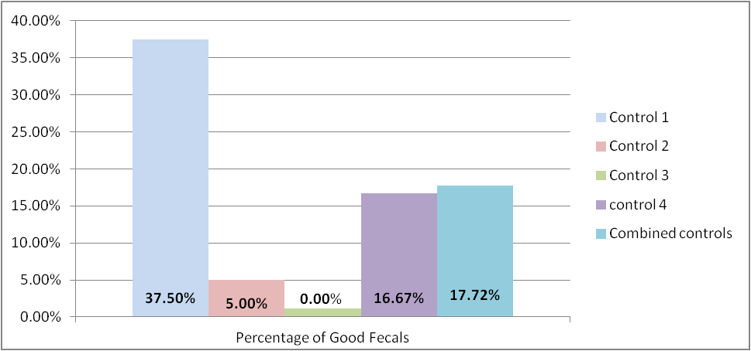

**Figure 2 - Control Stages - Percentages of Good Fecal Ratings during the Control Stages**

For the discussion, the combined control category will be used for comparison to the other stages of the study (see figure 3). Dairy free had the highest percentage of good fecal observations. The other categories had a percentage less than the controls, so it is assumed that they had little to no effect on stool consistency. When birth control was added, there were no days of good stools, so it can be assumed that hormones do play a role in stool consistency.

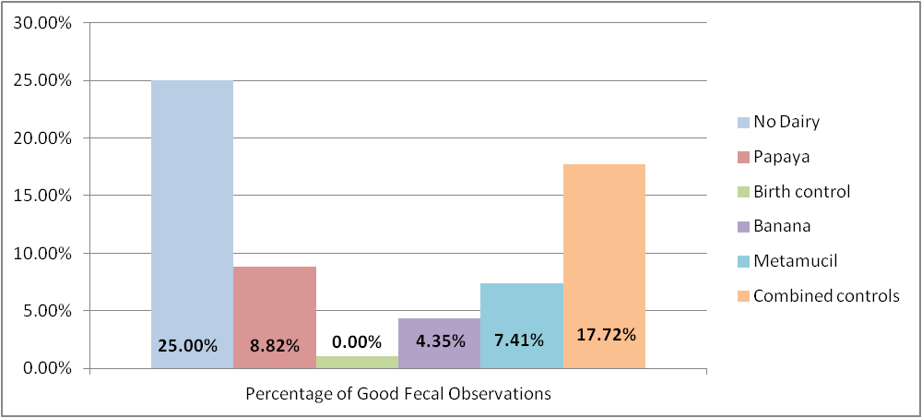

**Figure 3 - Percentage of Good Fecal Observations Compared by study phase**

The best stage in the study was the no dairy stage with 25.00% good results. The only dairy that is in the diet is yogurt and when we compare the diet in general, yogurt preceded good fecal observations 21.15% of the time. These two percentages are the two highest percentages of good fecal observations, even though they observe opposing factors (see figure 4).

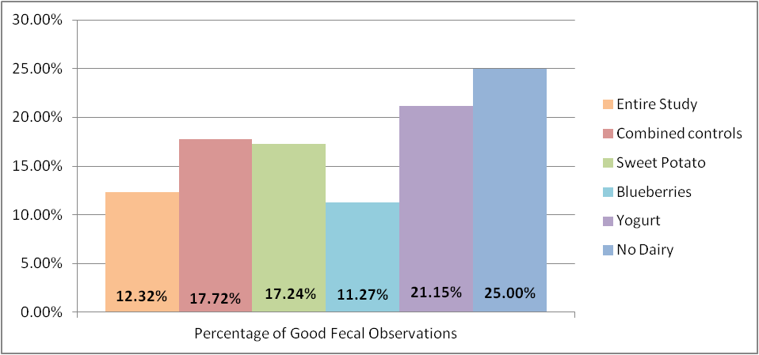

**Figure 4 - Percentage of Good Fecal Observations related to diet the day before**

Fecal color variances would have indicated a potential small intestine disorder. The feces were brown and light brown 96% of the time, which does not indicate any great color variety. When light brown and brown were compared, light brown stools resulted in good stools 4.82% more than brown stools. Yet when the averages were compared, the brown had a better average than light brown. Overall, color was not a factor that correlated to stool consistency in this study.

When the estrous cycle was analyzed (See Figure 5), there was some improvement seen when she had a smaller estrous swelling. This could have been caused by a small sample size. There were 121 days of data while she was at a level 1 estrous, compared to 13 days of data for a full estrous of 3-4. Since the number of days varies so greatly, there could be some discrepancies. To help counter than, we can combine the results of the lower estrous to the results of the higher estrous. That gives us 72 days of higher than 1 estrous swelling versus 135 days of estrous swelling of 1 or lower, which is more similar, and that gives us 7.24% compared to 13.75%, which is still a considerable difference. Neither category resulted in a good fecal consistently, but the smaller estrous swelling did have better feces than the larger swelling.

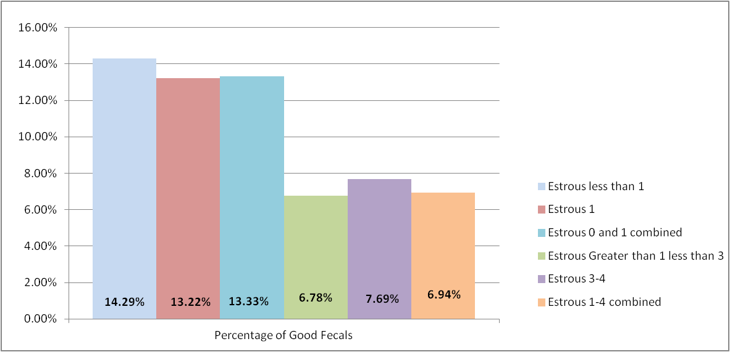

**Figure 5 - Percentage of Good Fecal Observations Compared by Estrous Sizes**

Most of the results look at the percentages of good fecal results during each stage. The averages were calculated as well, and when compared to the combined control average, the differences mimic the result of the percentages. Both the dairy free stage and the days following yogurt had lower, or better ratings than the controls. The other stages and the other areas examined all had higher fecal rating averages than the combined controls (See figure 6).

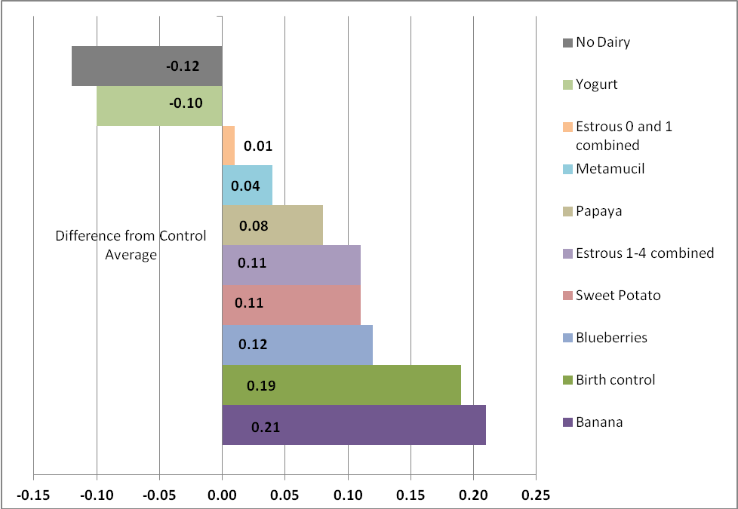

Figure 6 - Difference of Average fecal rating by stage compared to the Combined Control Stage Average

**Conclusions**

Though there was no obvious improvement in fecal consistencies, there was some improvement seen during the dairy free stage and also some improvement seen after yogurt was fed. Another dietary aid that could be tried is a dairy free probiotic to determine if the dairy in the yogurt was lowering the yogurt scores. Other options could be to try combining probiotics with a prebiotic. Since there was some effect with probiotics, the results could possibly be accentuated with prebiotics.

The only day a fecal rating of 2 was observed occurred on the last day of the study. This occurred a day after Maizey received about half of her normal amount of primate biscuits. This was due to a fellow cage mate that refused to shift which restricted the normal feeding routine. Further study with this is needed to see if fewer biscuits, or a biscuit free diet, or even gluten free biscuits could result in better fecal output.

Though the results were not as clearly defined or successful as originally hoped for, this was still a worthwhile study to do and continue. There are many possibilities that could still be tried with Maizey to improve her fecal consistency.

**Acknowledgments**

Special thanks go to the Houston Zoo for allowing this research project. Also thanks to the entire primate department; without everyone’s help this would not have been possible. Thanks to the Houston Zoo Veterinary Clinic staff who helped with medical background for this paper.

**Literature Cited**

Bateman, Graham. 1984. *All the world’s animals Primates.* New York: Torstar Books Inc.

de Vrese, Michael and Marteau, Phillippe R. 2007. *Probiotics and Prebiotics: Effects on Diarrhea.* American Society for Nutrition.

Jungers, W.L and Susman, R.L. 1984. *Body Size and skeletal allometry in African apes*. New York: Plenum Press.

Keeling, M.E. and McClure, H.M. 1974. *Pneumococcal meningitis and fatal enterobiasis in a chimpanzee*. Lab Animal Science. 24:92-95.

Lee, D. R. and Guhad, F. A. 2001. *Chimpanzee Health Care and Medicine Program.* Special Topics in Primatology. Volume 2. The Care and Management of Captive Chimpanzees. Edited by Brent, Linda. American Society of Primatologists. P 82-117.

Meester, J. and Setzer, H.W. 1977. *The mammals of Africa: an identification manual*. Washington, D.C.: Smithsonian Institute Press.

Nowak, Ronald M. 1999.*Walker’s Primates of the World.* Baltimore, Maryland: The Johns Hopkins University Press.

Pruetz, Jill D. E. and McGrew, William C. 2001. *What does a Chimpanzee Need? Using Behavior to Guide the Care and Management of Captive Populations.* Special Topics in Primatology. Volume 2. The Care and Management of Captive Chimpanzees. Edited by Brent, Linda. American Society of Primatologists. P16-37.

Swanson, Kelly S. et. al. 2002. *Effects of Supplemental Fructooligosaccharides and Mannanoligosaccharides on Colonic Microbial Populations*, *Immune Function and Fecal Odor Components in the Canine.* The American Society for Nutritional Sciences.

van Lawick- Goodall, J. 1968. *The behavior of free living chimpanzees in the Gombe Stream Reserve*. Animal Behavior Monograph. 1:165-311.

**Websites Cited**

1. The National Geographic Website <http://animals.nationalgeographic.com/animals/mammals/chimpanzee/>

2. The Jane Goodall Website

<http://www.janegoodall.org/chimpanzee-facts>

3. The Lance Armstrong Website

<http://www.livestrong.com/article/262595-what-are-the-causes-of-diarrhea-with-flatulence/#ixzz1wwGPkGK1>

4. The Doctor Cari Case Website

<http://forahealthyfuture.com/vitamins-supplements/papaya/>

5. The Lance Armstrong Website

<http://www.livestrong.com/article/500849-high-fructose-corn-syrup-fructooligosaccharide/#ixzz1xPs135OS>

6. The Washington State University, College of Veterinary Medicine Website

<http://www.vetmed.wsu.edu/cliented/diarrhea.aspx>

7. The Merck Veterinary Manual Website

<http://www.merckvetmanual.com/mvm/htm/bc/tdig01.htm>