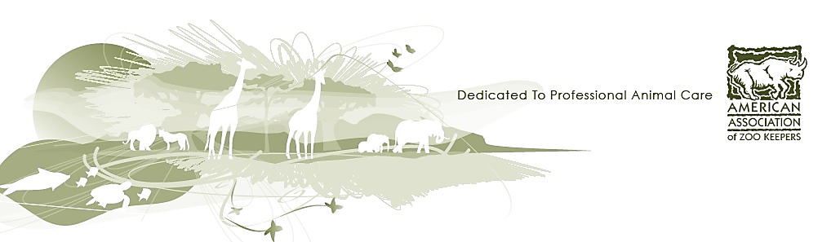

**American Association of Zoo Keepers**

**First Time Attendee Guide**

**AAZK National Conference**

This guide is a resource for new delegates attending the AAZK National Conference for the first time. It includes tips from prior attendees that will help you gain as much value as possible from attending the conference.

Here are some useful insights to help you get the most out of the conference, before, during and afterwards.

**BEFORE THE CONFERENCE**

* Register early if possible
* Each conference host will set a date where fees increase, usually 4-6 weeks prior to start
  + Certificate courses and workshops fill up quickly
* Check the Conference website and social media for links for roommate information
* Book a hotel room as early as possible; consider staying at the conference hotel or make sure the travel between your hotel and the host hotel is easily accessible. Please note there may be a deadline for booking a room at a reduced rate
* Consider airport travel; usually there are suggested shuttles and/or cab companies~~.~~ 
  + Use social media or the Conference App to look for people to share a ride
* Please note workshops and presentations will happen simultaneously so plan accordingly.
* Open Topical Workshops have unlimited attendance and do not require pre-registration
* Limited Topical Workshops could have a maximum number of participants (for example-40 participants.)
  + Each delegate is able to register for two Limited Topical Workshops for the whole week.
  + Some Limited Topical Workshops may have two parts.
    - Delegates will need to register for BOTH Part 1 and Part 2, and this will account for their total workshop opportunities.
* Create an “elevator” introduction for all the new people you will be meeting. Networking is very important.
  + The idea behind an elevator intro is that you are prepared to share what you desire to in a very quick amount of time; an elevator length ride.
* If you want to connect with a speaker, contact them on the Conference App or email them prior to the conference, if possible.
* Pre and Post Conference trips may be offered and are an excellent way to see other institutions, meet people before the conference, and continue learning after.
  + Specific information will be available on the conference website.
* Visit the hotel website in advance to see what amenities may be available

**A Note for Students**

* If you are under the legal drinking age this will be denoted in some manner on your AAZK Conference ID badge

**Attire**

* Follow institutional guidelines for attire when representing your institution.
* The Ballroom is always chilly; consider a sweatshirt or jacket
* Most delegates dress comfortably in casual attire, but presenters will often dress in business attire
* Most delegates dress up for the farewell banquet
* A Conference T-shirt is usually available as part of Registration and many delegates will wear this on Zoo Day.
* Otherwise, on zoo day, consider your choice of footwear since you are going to a zoo!

**DURING THE CONFERENCE**

**Daily Program**

* The Conference program with the daily schedule can be found on the host chapter website.
  + It will provide times for presentations, courses, events, and workshops during the week so that you can personalize your schedule when you register.
* Schedule and conference information will also be available on the Conference App
  + There is an exhibitor room; some exhibitors will have demonstrations, some have items to sell.
  + During the silent auction, typically both cash and credit cards are accepted

**Meals**

* The meal during the final banquet will be provided, but the Conference hosts are not responsible for providing any other meals during the week.
* If in use, the Conference App chat groups are a great resource for finding local and affordable places to eat, as well as finding a friend to dine with.
* BE GREEN! Bring your own water bottle, coffee mug, utensils, straws, bags, etc.

**Networking**

* The Icebreaker event is a great opportunity to connect with other delegates
* Bring business cards to exchange and be prepared to add contacts on social media.
* Your conference name badge is also a great conversation starter

**Zoo Day**

* Transportation for Zoo Day will be coordinated by the Host Chapter
* Tours will be set up by the Host Facility and will vary year to year in format
* Don’t forget your camera!

**POST CONFERENCE**

* Share your conference proceedings USB with the rest of your chapter and fellow keepers
* Follow up with people you met.
* Visit the AAZK website for more information on AAZK Committees and how you can get more involved.
* Complete any post conference surveys. Your feedback will help AAZK create a more enhanced conference experience
* Share photos!

**QUICK TIPS**

* Register early! Decide if you’d like to attend one of AAZK’s Professional Certificate Courses. Pack plenty of business cards
* Don’t have business card? Make use of social media, email, and the Conference App for contacts.
* Bring a reusable water bottle and/or coffee mug with you.
* Make sure you have a copy of the Conference program by downloading the Conference App to your phone or tablet.
* BE GREEN! Check the availability of Wi-Fi access to take notes on a computer or smartphone.
* Take advantage of the conference breaks to refresh your mind, network and meet new people
* Have fun!

**_________________________________________________________________________________**

**2018 AAZK NATIONAL CONFERENCE HOST**



**Denver AAZK**

Email: [aazkdenver2018@gmail.com](mailto:aazkdenver2018@gmail.com)

Conference website: <http://aazk2018.webs.com/>

Facebook page: <https://www.facebook.com/AAZK2018/>

**Conference Manager**

Bethany Bingham

[bethany.bingham@aazk.org](mailto:bethany.bingham@aazk.org)



Document produced by the

AAZK Resource Committee