**How to Prepare Your Sea Lion for Surgery**

Lindsey Bicksler and Celeste Harris

Sea Lion Trainers

Birmingham Zoo

**The Problem**

The Birmingham Zoo’s female California Sea Lion, Giovanni, had an abscess under her chin that was not responsive to various antibiotics for several months. Giovanni was trained to hold for manipulation of the abscess and to allow a culture to be collected. The results of the culture tested positive for pseudomonas, a type of bacteria that is resistant to antibiotics.

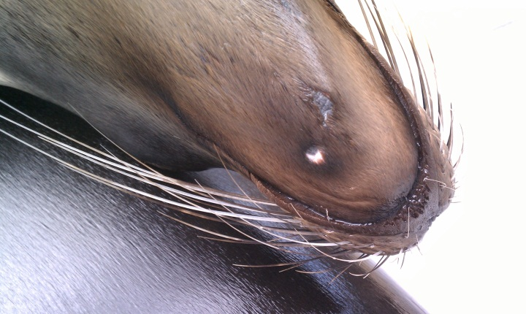

Giovanni’s abscess began as a small spot under her chin

**The Solution**

The veterinary staff requested radiographs of the abscess to determine the source of the infection. Sea lion trainers made plans to train Giovanni to allow voluntary radiographs to avoid immobilization. Although Giovanni had already been trained to allow radiographs of her flippers, trainers now needed to desensitize her to the x-ray plate around her mouth. Staff also needed to desensitize her to the vet technician, as well as the gloves and vest needed for the procedure. The initial training sessions included a box covered in a yellow raincoat to simulate the vet staff’s x-ray machine, which was bright yellow. Over the course of one week, trainers introduced one new item each day, including the vet technician.

Trainers focused on three different positions to take x-rays. First, Giovanni was positioned on her platform with her mouth opened and her chin resting on the x-ray plate. Though the x-ray plate would be touching her chin, technicians thought the shot might not be very clear due to the probability of her top jaw obstructing the view. To address this, trainers had Giovanni bite down on the x-ray plate. This was a better shot due to fewer obstacles; however it was slightly difficult for the technician to aim the machine. This resulted in the third position, which involved Giovanni lying on her back with the x-ray plate in her mouth. This provided the technician with the best position for the shot. However, this was a vulnerable position for Giovanni and she would often break from the session.

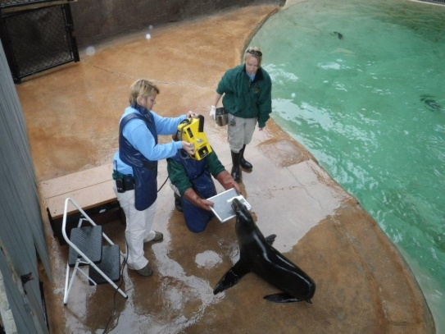 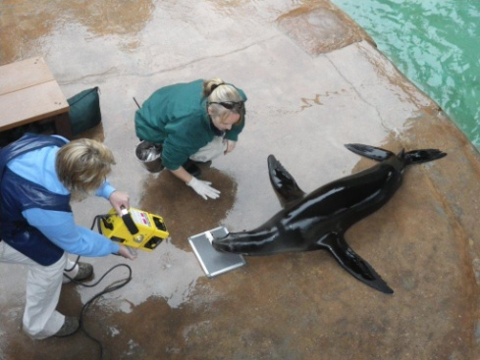

Trainers working with Giovanni to allow voluntary x-rays of her mouth

When Giovanni seemed comfortable with all of the props, trainers brought in the actual x-ray machine for a few trial shots. During the session, trainers also tried a fourth position with Giovanni lying on her stomach with the x-ray plate under her chin with the technician above her. Vet technicians found that the position with Giovanni on her back with the plate in her mouth was the best angle for a clear picture. After two sessions of shooting x-rays, technicians were able to get a clear picture of the problem; there was a cystic lesion on the root of Giovanni’s left canine tooth.

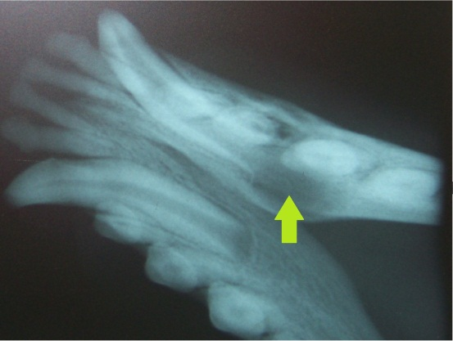

The arrow indicates the infected area under

Giovanni’s canine tooth

**Now What?**

In order to get rid of the infection, Giovanni’s left canine was scheduled to be extracted, which would require an immobilization. Unfortunately, the zoo did not have a squeeze cage that would be suitable for Giovanni’s size. Trainers decided to train Giovanni to voluntarily participate in as much of the immobilization process as possible. However, due to the dentist’s schedule, the surgery was scheduled only ten weeks away.

**Let’s Get Training!**

The veterinary staff suggested that Giovanni be trained to accept a sedative injection. While Giovanni was already very comfortable with tactile behaviors, she had not previously been trained to accept an injection, so trainers started with this immediately. After three weeks of using pen caps and fingernails, Giovanni was accepting a .20 gauge needle. However, in the fourth week, Giovanni started reacting negatively to the needle by pulling her rear flippers under her body when the needle was applied. She also became less reliable shifting into the area where the training was occurring. At this point, trainers focused on making this behavior more rewarding for Giovanni by reinforcing heavily with primary and secondary (tactile) reinforcement. Trainers also attempted to keep it novel by only asking for the behavior once a day. Finally, trainers started training this behavior first thing in the morning, not only to simulate the time at which the procedure would occur, but to make sure Giovanni was motivated to work.

Trainers also made sure to make the area where the immobilization training was taking place as positive as possible. To do this, trainers would take Giovanni into this area during the day but not ask any immobilization behaviors. Trainers would also offer her tactile reinforcement while in this area. Within seven weeks, Giovanni was only tucking her rear flippers in on occasion and not breaking from the session. In eight weeks, Giovanni was accepting 0.5mL of saline and by ten weeks Giovanni had reached the trainers’ target goal of receiving 2.5mL of saline.

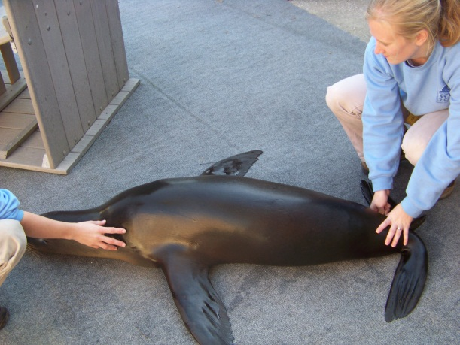 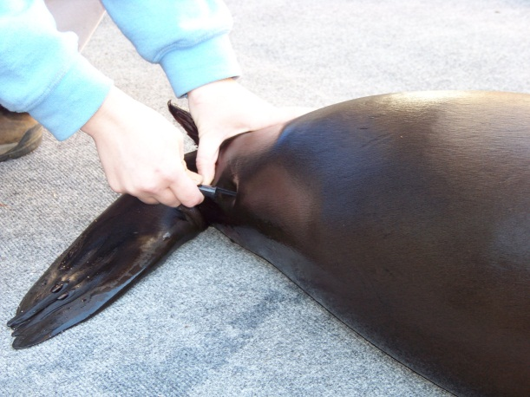

Trainers use a pen cap to initially train injection

Along with injection, trainers were also working with Giovanni to allow sedation using a gas mask and isoflurane (ISO). Vet staff had constructed a mask made of a nolvasan bottle wrapped in vet tape. Within one week, Giovanni was putting her face into the mask. During week two, trainers introduced Giovanni to ISO gas. She did pull her face out of the mask at first exposure, but did not completely break from the session.

Unfortunately, Giovanni started to hold her breath when the mask was on. Waiting for Giovanni to breathe was not an option due to the length of time it would take for sedation, therefore trainers needed to come up with another solution. To overcome this, trainers taught Giovanni to breathe on cue. Giovanni was previously taught to exhale on cue to blow a whistle. This exhale behavior allowed the trainers to capture the inevitable inhale, and trainers attached the verbal cue “breathe” and the visual/tactile cue of tapping Giovanni on the forehead. This behavior was practiced with and without the mask on.

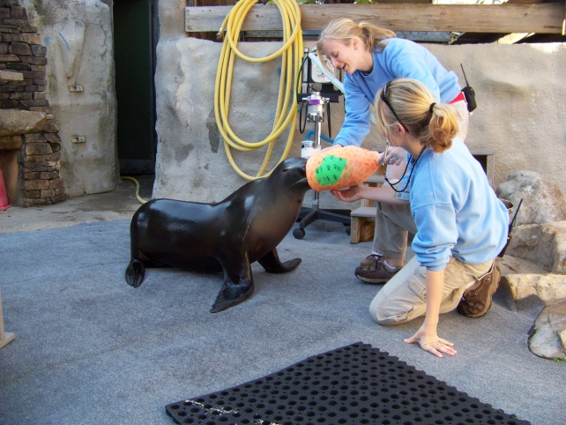 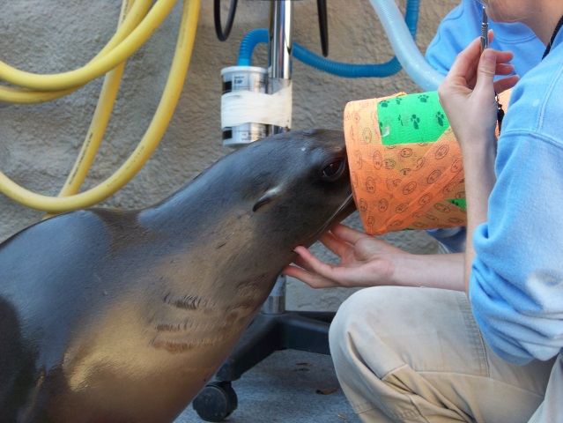

Trainers work on voluntary gas mask (isoflurane)

In three weeks, Giovanni was inhaling oxygen and isoflurane two to three times per week, when veterinary staff was available to bring the anesthesia machine. During the rest of the week, trainers focused on increasing the amount of time Giovanni had to breathe with the mask on. In four weeks, Giovanni was breathing with the mask on for 30 seconds. However, in five weeks Giovanni was refusing to put her face in the mask or breaking from the session. Trainers decided to also make this training as reinforcing to Giovanni as possible, similar to injection training. With the small amount of time left, trainers decided to desensitize Giovanni to manual restraint positions.

In addition to training voluntary restraint, trainers decided to come up with more specific goals for Giovanni each week, with the end result being achieved one week in advance of immobilization day. This gave trainers smaller goals to focus on, rather than becoming stressed over all that they needed to achieve in five weeks. The final goal was for Giovanni to go into a down position and allow the mask to be put over her face. She would then breathe on cue and inhale isoflurane for three minutes. Simultaneously, Giovanni would also accept a mock sedative (saline) injection of 2.5mL. A total of four staff members needed to be present for this training.

In six weeks, Giovanni was allowing trainers to manipulate her flippers against the side of her body. In seven weeks, Giovanni was allowing a trainer to kneel over her body while the mask was on her face. In eight weeks, Giovanni was holding for 90 seconds and breathing several breaths of isoflurane with or without another trainer kneeling over her body. During weeks nine and ten, Giovanni was giving trainers mixed results during sessions. Some training sessions were much better than others and vet staff was not always available to bring the anesthesia machine. Although trainers did still continue with gas mask training, more focus was put on injection and restraint behaviors.

Immobilization day arrived and Giovanni accepted the sedative injection. Although trainers were ready with the anesthesia machine, Giovanni was calm throughout the process and the sedative injection was enough to allow trainers to move her onto the surgery table.

**Success and Challenges**

During the first five weeks, the final goal seemed overwhelming to trainers. Setting small goals during this frustrating time helped trainers focus on moving forward one step at a time. Trainers decided to increase the amount of saline injected by 1.0mL each week, increase the amount of time the mask was on by 45 seconds each week and increase the number of people by one person each week. Focusing on the smaller goals, and taking each week on separately, helped trainers to realize that the final goal was attainable.

One of the biggest challenges was the limited availability of the vet staff, which in turn limited access to the anesthesia machine and isoflurane gas. Initially, vet staff helped two days out of the week. This was increased to three times a week halfway through the training process. However, trainers were still training the behaviors every day. Trainers may have had better success if these materials had been available every day, making the training process more consistent.

Immobilizing pinnipeds is always high risk, but through training, the procedure went smoothly and stress to both Giovanni and the staff was minimized. Choosing to train Giovanni to voluntarily participate in as much of the procedure as possible helped both trainers and Giovanni gain confidence with all aspects of the surgery. Even though most of the newly trained behaviors were not needed, trainers felt that the process was still beneficial for Giovanni. It not only helped her to be comfortable with all the different aspects of the immobilization, but it also gave a basis of training for any future immobilizations.

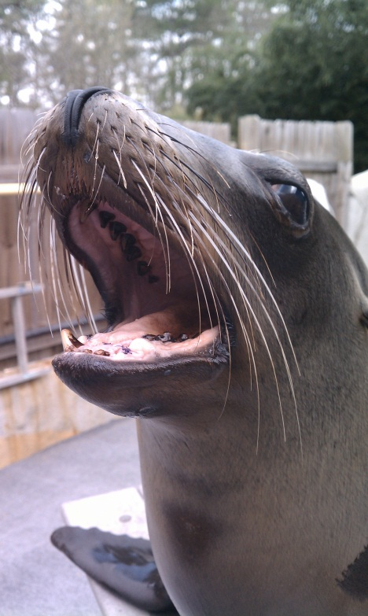

Giovanni is recovering well

after surgery