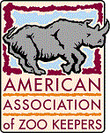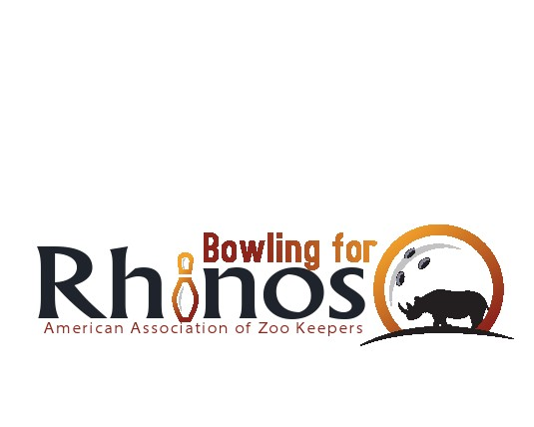

Dear “**Bowling For Rhinos”** Friends and Family,

Thank you for supporting the 20_ **“Bowling for Rhinos”** fund raiser. The American Association of Zoo Keepers (AAZK) has now raised over $5 million since 1990. 100% of your contribution continues to be sent directly to conservation projects protecting the 5 species of rhino.

Kenya's black rhino population went from 20,000 in the mid 1970's to a few hundred by 1986. Conservation organizations went to work and today there are over 1,000. The Lewa Wildlife Conservancy (LWC) has 10 % of the National population of black rhino and 15 % of the world's population of Grevy's zebra. Wildlife thrives in this safe haven and LWC continues to be a model for conservation worldwide.

The International Rhino Foundation (IRF) in Indonesia continues to train Rhino Patrol Units (anti-poaching teams) and beef up security. In the 1980's, there were still about 1,000 Sumatran rhinos. By 1995, there were only 300 left. Over the past 8 years, with the RPUs in place, this number has remained stable. The goal now is to curtail poaching and habitat destruction and then allow the populations to rebound to viable size. If we are successful in conserving the rhino's ecosystem, we can at the same time save some of the most biologically important places on earth and greatly improve the odds for countless other species struggling to survive in the wild.

Action for Cheetahs in Kenya (ACK) actively works on cheetah conservation in the shared habitat as occupied by black and white rhinos.

Without safe havens such as Lewa, Ujung Kulon, Way Kambas and Bukit Barisan, many of these animals would surely perish. The success of these areas in conservation of wildlife is largely due to your generous support. I hope you will feel proud in knowing that you have helped save wildlife worldwide. Your support truly does make a significant difference.

Sincerely,