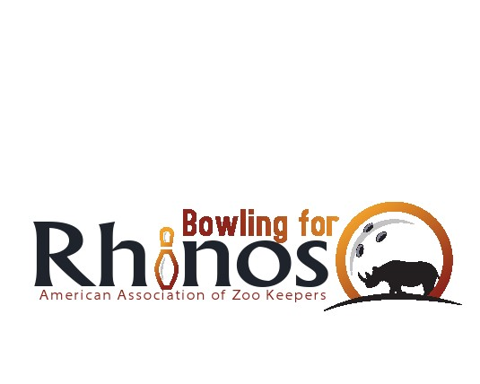

Dear friends and family,

Extinction is forever. Endangered means there is still time… Rhinos have lived on earth for over 50 million years. In the past, rhinos were much more diverse and widespread. Today only 5 species survive and all are under threat of extinction. Only 17,500 of these marvelous creatures survive in the wild with another 1,200 in captivity. Of these rhinos, almost two thirds are of a single subspecies: the Southern White Rhino. There are fewer than 6,000 of the other 4 species combined. Without drastic action, rhinos could be extinct in the wild within the next 10 years.

The American Association of Zoo Keepers (AAZK) and Bowling for Rhinos (BFR) is that drastic action. AAZK has made definitive progress through BFR. Without successful conservation partnerships and your support, it’s most likely some species of rhino would surely be extinct today. It is in all of our hands to continue this work to protect these animals and have their numbers return to sustainable populations.

Over the past 25 years the rhino project in Kenya has evolved from a 10,000 acre rhino sanctuary into the 75,000 acre Lewa Wildlife Conservancy (LWC), partnered with the Northern Rangelands Trust. LWC has become one of the most successful rhino sanctuaries in all of Africa and serves as a model for wildlife co-existing with surrounding communities. To learn more, visit: www.lewa.org

To conserve Asian species of rhino, AAZK partners with the International Rhino Foundation (IRF) for the protection Javan, Sumatran and Indian rhino on protected sanctuaries. To learn more about conserving Asian species visit: [www.irf.org](http://www.irf.org).

In 2006 – AAZK expanded our species conservation to include cheetah, as the cheetah and rhino share the same habitat in Kenya. Partnering with Action for Cheetahs in Kenya (ACK) an entity of the Cheetah Conservation Foundation, AAZK is now a global species conservator. To learn more, visit www.actionforcheetahs.com

I hope you will again consider contributing to this worthwhile cause and continue the campaign to keep these animals part of our heritage. Your tax-deductible contribution* prior to **[insert your event info here]** would be greatly appreciated. I sincerely thank you.

Please send to:

**[insert your info here]**

Sincerely,

Make **checks payable to: “[insert your info here]”**

*If you work for a company that matches its employees’ gifts, please obtain a matching gift form from your human resources office and enclose it with your contribution.