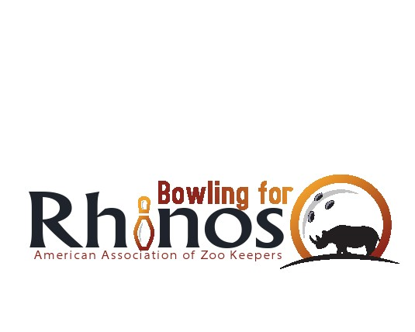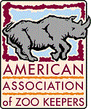

Dear Friend of Rhinos:

Chapter EIN ________________

Thank you for supporting the American Association of Zoo Keepers 201_ **“Bowling for Rhinos”** fund raiser with aprize donation. AAZK and its subordinate Chapters are a 501 (c)(3) federal non-profit entity that proudly claims 100% of all contributions are sent directly our partners in conservation Lewa Wildlife Conservancy (LWC) Kenya, International Rhino Foundation (IRF) Ujung Kulon National Park in Java, Indonesia and Bukit Barisan Selatan and Way Kambas National Parks in Sumatra, Indonesia. And Action for Cheetahs in Kenya (ACK).

Your prize donation(s) of ___________________________________ help us to attract more bowlers to our event, raising more money and awareness on the plight of the rhino and endangered species worldwide. AAZK’s Bowling for Rhinos supports conservation of habitat in the wild. By protecting these unique ecosystems, we not only save the rhino but everything living in the rhino’s habitat from orchids to elephants.

Once again, we thank you for your support and hope you share in our celebration of the overwhelming success in helping these magnificent endangered animals. It is due to your generous contributions that many of these animals may survive and be seen in the wild for future generations.

Please keep us in mind next **[insert date of your future event here]** for the most successful **201_ Bowling for Rhinos** event in our history.

Sincerely,