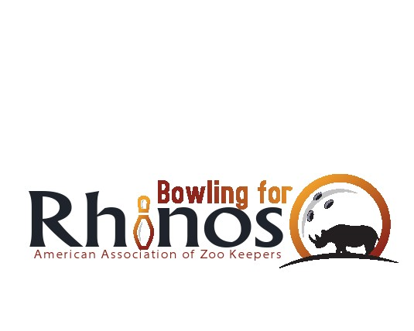

Dear Friends of Conservation:

In a continuing effort to help protect rhino and other endangered species, animal keepers throughout the world through the American Association of Zoo Keepers’ Bowling for Rhinos conservation program are holding a "**Bowling For Rhinos**" fund raiser.

Now in its 25th years with over 5 million dollars raised AAZK’s BFR is one of the few fund raisers that can claim 100% of all proceeds will go directly to support species through Lewa Wildlife Conservancy (LWC) in Kenya. LWC is a 65 thousand acre sanctuary which not only saves the black rhino but everything from orchids to elephants within the sanctuary. In partnership with Action for Cheetahs in Kenya (ACK) BFR now works to protect cheetah on shared habitat in Kenya.

Asian species are conserved in sanctuaries located in Ujung Kulon National Park in Java, Indonesia and Bukit Barisan Selatan and Way Kambas National Parks in Sumatra, Indonesia through the International Rhino Foundation (IRF). Ujung Kulon is a 300 square mile National Park which is home to the last 47 Javan rhinos in the world! Bukit Barisan Selatan National Park is a 3,500 square km lush, lowland, tropical rainforest where rhino Sumatran tigers and Malayan sun bear are at critical survival numbers.

The American Association of Zoo keepers (AAZK) expresses its concern over the plight of the all species by taking action. We raise enough money to protect and conserve these valuable ecosystems for future generations.

The [**insert your chapter here**] chapter of AAZKwill hold its "Bowling for Rhinos" event on **[insert your event time/place here].**

AAZK is a 501(c)(3) Non-profit entity. This can be your company's opportunity to be a strong voice in the worldwide conservation effort to protect endangered and threatened species. Please consider donating a raffle or door prizes to this **(Insert your Event Name Here)** and consider forming an employee team and bowlwith **[insert your ZOO NAME here]** and our animal staff in this important, but fun event. For additional information please contact:

[insert your contact info here].

Sincerely,