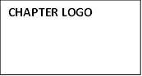
C/O YOUR NAME
ADDRESS

DATE
CONTACT NAME
ADDRESS

Dear _____:
The American Association of Zoo Keepers and its’ subordinate Chapters are a federal 501c3 non-profit organization (Chapter EIN ______________) and will supply an IRSW9 upon request. In a continuing effort to help protect endangered rhinos as well as the ecosystems they live in, Chapters of the American Association of Zoo Keepers (AAZK) throughout the nation, each sponsor an annual “Bowling for Rhinos” fundraising event.
Thank you to our previous year’s supporters of our Bowling for Rhinos fundraiser. Last year, we were able to raise $_____, due to generous donations like your company’s. Nationally, we have raised over $4 million, since 1990. Our goal this year is to continue to grow our sponsorships from companies like yours in a continuing effort to help protect endangered rhinos.
The CHAPTER NAME event will take place DATE, TIME AND PLACE. 100% of all donations will go directly to support conservation effort to save all 5 endangered rhino species in their native habitats of Kenya, Indonesia, and India. The Lewa Wildlife Conservancy, The International Rhino Foundation and Action for Cheetahs in Kenya are being helped to save rhinos and their ecosystems by generous people like you.
We would like to invite you to participate by helping sponsor the event with a monetary donation or auction item. We have Rhino Donation levels available:
Javan (40- 50 individuals left in the wild) $200 and above
Sumatran (200) $150-$199
Indian (2850) $100 - $149
Black (4860) $51 - $99
White (20,000) Up to $50

Your company will be recognized in promotions before, during and after the event on our website, Facebook (IF HAVE), flyers, posters and more.
Will you please consider a donation to help save these valuable ecosystems for the children of the next generation to experience? Please contact or mail items C/O NAME, TITLE, ADDRESS. We would like to receive all donations by DATE. Please give us the approximate value of any items you donate. We are available to pick up any donations or provide a tax receipt.
Thank you for your consideration and you may contact us at EMAIL ADDRESS with any questions. For more information about Bowling for Rhinos, please visit www.aazk.org
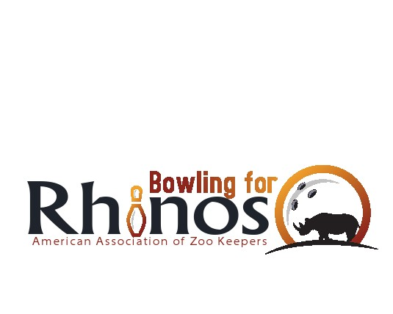
Sincerely,

NAME AND TITLE (i.e. Bowling for Rhinos Chair)
